PHYSICS NOTES
Kyla Orchard
contents:
GRAVITY AND MOTION 6
PROJECTILE MOTION 6
HORIZONTAL CIRCULAR MOTION 8
VERTICAL CIRCULAR MOTION 10
GRAVITATIONAL FIELDS AND SATELLITE MOTION 11
TORQUE 13
ELECTROMAGNETISM 20
ELECTRIC FIELDS AND FORCES 20
MAGNETIC FIELDS AND FORCES 21
THE MOTOR EFFECT 28
ELECTROMAGNETIC INDUCTION AND FARADAY’S LAWS 30
GENERATORS – AC AND DC 34
POWER TRANSMISSION 36
TRANSFORMERS 37
~~*NOTES FROM BOOKLETS*~~ 37
ELECTROMAGNETISM 37
WAVE PARTICLE DUALITY AND THE QUANTUM THEORY 38
WAVE PARTICLE DUALITY 38
THE PHOTOELECTRIC EFFECT 43
ELECTROMAGNETIC RADIATION 47
ATOMIC SPECTRA AND BOHR’s MODEL OF THE ATOM 50
SPECIAL RELATIVITY 57
RELATIVE MOTION 57
THEORIES OF RELATIVITY 58
THE STANDARD MODEL 64
THE HISTORY OF PARTICLE ACCELERATORS 64
EVIDENCE FOR THE BIG BANG 68
STORY OF QUARKS 74

Other things to note:
- Simultaneous equations for horizontal and vertical motion
- Kepler’s 3rd law derivation (mv²/r = GmM/r²)

Equations:

$v=\frac{distance}{time period}=\frac{2πr}{T}$
v = circular speed (m/s)
r = radius of path (m)
T = period (time of one rotation) (s) (also equal to 1/frequency)

$v=\sqrt{rgtanθ}$
$v_{0}=\sqrt{rg}$

NEWTON’S LAW OF UNIVERSAL GRAVITATION
$F_{g}=G\frac{m_{1}m_{2}}{r^{2}}$
F_{g} = gravitational force acting on the body (N)
G = universal gravitational constant (6.67 x 10⁻¹¹ N.m².kg⁻²)
r = distance between the bodies centres of mass (m)
m₁ and m₂ = masses of the bodies (kg)

GRAVITATIONAL FIELD STRENGTH
$g=\frac{GM}{r^{2}}$
g = gravitational field strength (N.kg⁻¹)
G = universal gravitational constant (6.67 x 10⁻¹¹ N.m².kg⁻²)
M = mass of object around which the gravitational field spreads (kg)
r = distance from the centre of mass of the object

TORQUE
$τ=r_{⊥ }F$
$τ$ = torque (Nm)
$r_{⊥ }$= perpendicular distance to the pivot point (m)
F = force (N)

when the force isn’t perpendicular:
$τ=r_{ }F sinθ$

ELECTRIC FIELDS
$E=\frac{F}{q}$
F = force (N)
E = electric field (N.C⁻¹)
q = electric charge (C)

another way to write for parallel plates:
$E=\frac{∆V}{d}$
E = electric field (N.C⁻¹)
$∆$V = potential difference (V)
d = separation between plates (m)

combining the equations
$F=\frac{q∆V}{d}$
$W_{d}=q∆V$
Since $W=∆E$
$∆KE=q∆V$

MAGNETIC FIELD CAUSED BY A STRAIGHT CURRENT-CARRY WIRE
$B=\frac{μ_{0}I}{2πr}$
B = magnetic field (T)
I = current (A)
r = distance from wire
$μ_{0}$ = permeability of free space

$F_{B}=qvB$ and $F_{c}=\frac{mv^{2}}{r}$
$F_{B}=F_{c}$
$qvB=\frac{mv^{2}}{r}$
$r=\frac{mv}{qB}$

MAGNETIC FLUX
$∅=BA$
$∅$ = magnetic flux passing through the coil (Wb – Weber)
B = magnetic flux density (T)
A = area of the coil perpendicular to the direction of the magnetic field (m²)

FARADAY’S LAW
$ε=-N\frac{∆∅}{∆t}$
$ε=-N\frac{∆(BAcosθ)}{∆t}$
N = number of turns on the wire

Voltage in primary coil: $V_{p}=N_{p}\frac{∆B}{t}$
Voltage in the secondary coil: $V_{s}=N_{s}\frac{∆B}{t}$
Ratio of the voltage to the number of turns in the coil:
$\frac{V_{s}}{V_{p}}=\frac{N_{s}}{N_{p}}$

ENERGY OF A PHOTON
$E=hf$
E = energy (J)
H = Planck’s constant ($6.63×{10}^{-34}$ J.s)
f = frequency (Hz or s⁻¹)

KE vs $λ$
$E=hf$
$v=λf$
Combining these equations:
$E=\frac{hv}{λ} or \frac{hc}{λ}$
As v = c for light

PHOTOELECTRIC EQUATION
$E_{K}=hf-W$

ELECTROMAGNETIC RADIATION
For all EMR in a vacuum: $v=c ∴f=\frac{c}{λ}$

Energy carried by EMR $∝$ f
$E=hf=\frac{hc}{λ}$

ELECTRONS MOVING BETWEEN ENERGY LEVELS
If an electron in an atom moves between energy levels m and n, the energy of the photon that is either emitted or absorbed is given by:
$E_{photon}=hf=E_{m}-E_{n}$
h = Planck’s constant ($6.63×{10}^{-34}$ J.s)
f = frequency of the photon (Hz)
if eV or J are used, they must remain consistent

ENERGY LEVELS FOR HYDROGEN
$E_{n}=\frac{-13.6}{n^{2}}$
$E_{n}$ = energy of the nth level for hydrogen (eV)
n = the energy level number (1, 2, 3, …)

DE BROGLIE WAVELENGTH
$λ=\frac{h}{p}=\frac{h}{mv}$
m = mass of the particle
v = speed
$λ$ = de Broglie wavelength of the particle (m)
h = Planck’s constant
p = momentum of the particle (kg m s⁻¹)
*the electronvolt value of Planck’s constant does not apply when using this formula*

THE EFFECT OF SPEED ON MOMENTUM
The analysis of collisions between 2 particles shows that if we want to preserve the law of conservation of momentum in relativity, we must redefine relativity as:
$p=\frac{mv}{\sqrt{1-\frac{v^{2}}{c^{2}}}}=γmv$
At very low speeds this equation reduces to the classical momentum equation $p=mv$

THE EFFECT OF SPEED ON ENERGY
As the momentum of an object increases, so does its kinetic energy
$E_{k}=\frac{1}{2}mv^{2}$
$=\frac{1}{2}(mv)×v$
$=\frac{1}{2}pv$

$E_{total}=E_{0}+E_{k}$
$=mc^{2}+\left(γ-1\right)mc^{2}$
$=mc^{2}+γmc^{2}-mc^{2}$
$=γmc^{2}$

RELATIVISTIC ENERGY
$E=\frac{mc^{2}}{\sqrt{(1-\frac{v^{2}}{c^{2}})}}$

RELATIVISTIC ADDITION OF VELOCITIES
$u=\frac{v+u'}{1+\frac{v u'}{c^{2}}}$

$u'=\frac{u-v}{1-\frac{u v}{c^{2}}}$
u’ = velocity of an object moving in frame S’
u = velocity of the same object as viewed from frame S
v = relative velocity between reference frame S and S’

THE SPECTRA OF GALAXIES
- Hubble observed and recorded spectra of faint galaxies
- He compared them with spectra of laboratory standards and calculated their velocities
$v=\frac{Δλ}{λ}×c$

HUBBLE’S LAW
He plotted their distance against velocity and developed Hubble’s Law, which states:
The rate at which astronomical objects move apart from each other is proportional to their distance from each other.
$v = HσD$
$Hσ$ = the Hubble constant
D = the distance to a galaxy
v = its velocity

unit three

GRAVITY AND MOTION

PROJECTILE MOTION
WHAT IS A PROJECTILE?
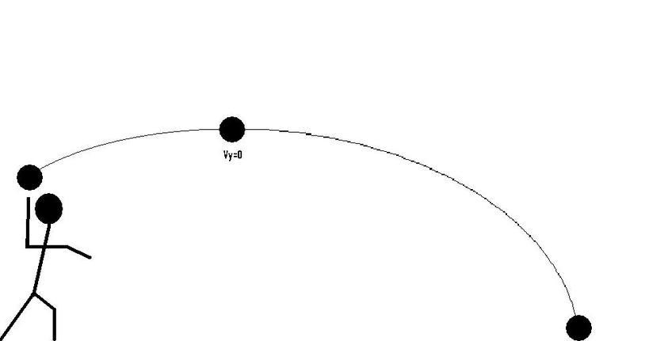
- Any object that is thrown or projected into the air and is moving freely (i.e., has no power like a rocket)
- If they are not launched vertically and air resistance is ignored – move in parabolic path
- The horizonal motion of the launched projectile has no effect on its vertical motion (and vice versa)

vertical and horizontal vector components are two separate things, linked by time of flight (t)
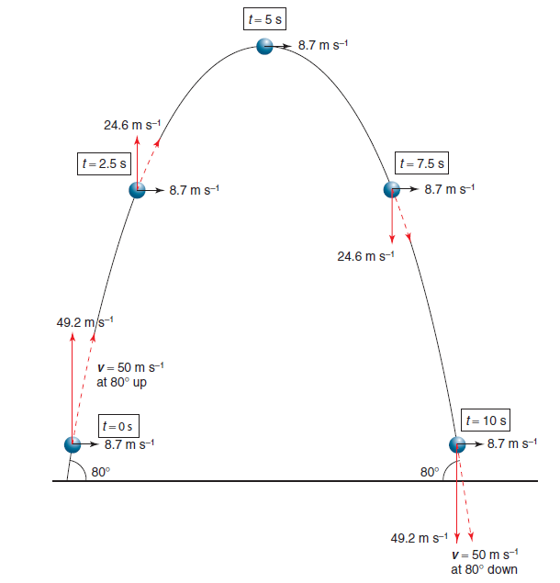
at the same displacement, v = same (but + vs -)
horizontal motion is the same for the whole flight

PROJECTILE MOTION
If air resistance is ignored, only force acting on projectile during flight = gravity (F_{g})

Vertical component
Acceleration = 9.8 m.s⁻² downwards
can be used to determine the time of flight of the projectile and the max height

Horizontal component
moves with uniform (constant) velocity
can be used to determine the range (horizontal distance), angle of projection, initial velocity and time of flight

Vector components
- The horizontal and vertical components used must be at right angles
- Horizontal component = vector cos θ
- Vertical component = vector sin θ
- θ must be the angle adjacent to the horizontal component

TYPE 1 – VERTICALLY
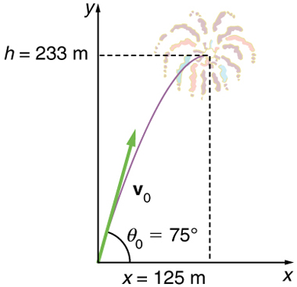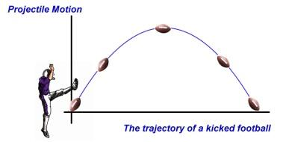

TYPE 2 – HORIZONTALLY
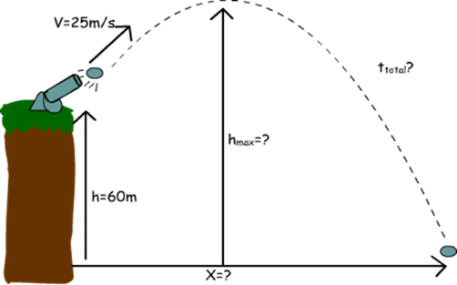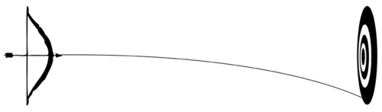

TYPE 3 – COMBINED
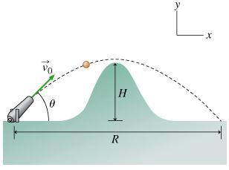

HORIZONTAL CIRCULAR MOTION
3 TYPES:
- ball on a string
- banked track
- leaning into a corner
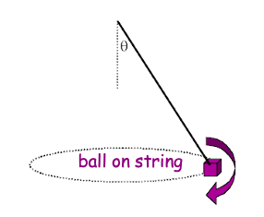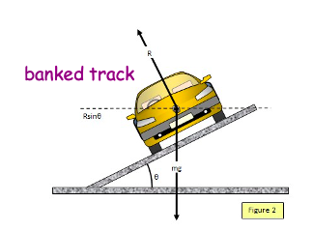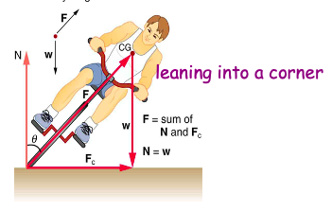

The average speed of an object moving in a circular path is:
$v=\frac{distance}{time period}=\frac{2πr}{T}$
v = circular speed (m/s)
r = radius of path (m)
T = period (time of one rotation) (s) (also equal to 1/frequency)
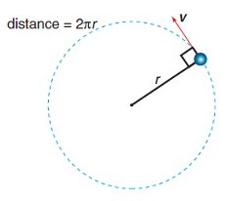

Centripetal acceleration is always directed towards the centre of the circular path and is given by:
$a_{c}=\frac{v^{2}}{r}$
Centripetal force is given by:
$F_{c}=ma_{c}=\frac{mv^{2}}{r}=\frac{m4π^{2}r}{T^{2}}$

WHAT CAUSES CENTRIPETAL FORCE?
System | Source of Centripetal Force
Ball on string | Tension force of string
Moon in orbit | Gravitational force
Electron in orbit | Electrostatic force
Circling ice skater | Normal reaction force of ice
Racing car turning on banked track | Normal reaction force of track
Centripetal force is not a real force and it is always caused by some other force
(drawn as a dotted line)

BANKED TRACKS
the banking angle required for a particular speed so that the banked track provides all the centripetal force, we use:
$v=\sqrt{rgtanθ}$

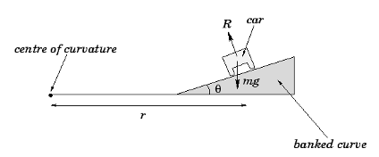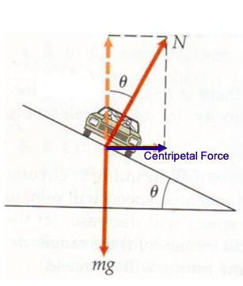
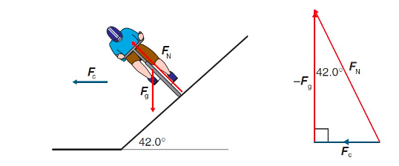

LEANING INTO A BEND
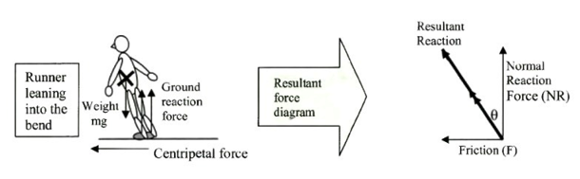
Friction provides the centripetal force

VERTICAL CIRCULAR MOTION
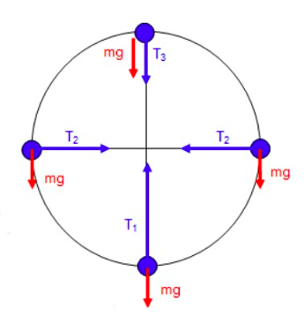
VERTICAL CIRCULAR MOTION
Ball on a string
Bottom: $T=F_{c}+F_{m}$
Top: $T=F_{c}-F_{m}$
Sides: $T=F_{c}$

Towards the center = positive
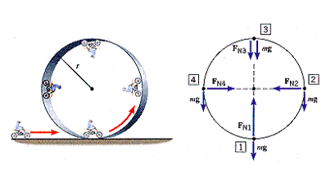

Roller Coaster
Bottom: $F_{c}=R+mg$ or $R=F_{c}+F_{m}$
Top: $F_{c}=R-mg$ or $R=F_{c}-F_{m}$
Sides: $R=F_{c}$

In place of tension, the reaction force from the ground is used
F_{m} = weight force or force from mass (W)

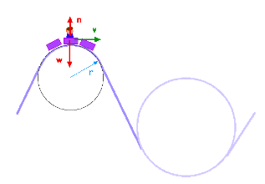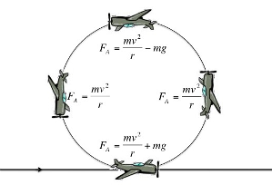

G-FORCES, ROLLER COASTER LOOPS AND WHY YOU DON’T FALL OUT
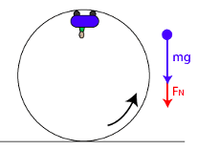
- weightless is when the F_{c} is equal to your weight
  - this is where the normal force is = to exactly 0
  - meaning the rails of the track are no longer pushing on the rollercoaster cart
  - if F_{c} is a little bit less, the cart is falling off the rail

VELOCITY REQUIRED FOR WEIGHTLESSNESS
Weightless means normal force (F_{N}) = 0
$F_{net}=F_{g}+F_{N}$ but $F_{N}=0$ so:
$F_{net}=F_{g}$
Therefore: $\frac{mv^{2}}{r}=mg$
$v^{2}=\frac{mgr}{m}$
$v^{2}=gr$
$v=\sqrt{gr}$
$v_{0}=\sqrt{rg}$

Max speed to not be a projectile, min speed to clear the upside-down section

G FORCES
g­force = Reaction (or Normal) Force divided by Gravitational Force
$g_{f}=\frac{R}{F_{g}} or \frac{N}{F_{g}}$
Reaction force or normal force

GRAVITATIONAL FIELDS AND SATELLITE MOTION
4 Fundamental Forces:
- strong force
- weak force
- electromagnetic force
- gravitational force

NEWTON’S LAW OF UNIVERSAL GRAVITATION
$F_{g}=G\frac{m_{1}m_{2}}{r^{2}}$
F_{g} = gravitational force acting on the body (N)
G = universal gravitational constant (6.67 x 10⁻¹¹ N.m².kg⁻²)
r = distance between the bodies centres of mass (m)
m₁ and m₂ = masses of the bodies (kg)

GRAVITATIONAL FIELD LINES
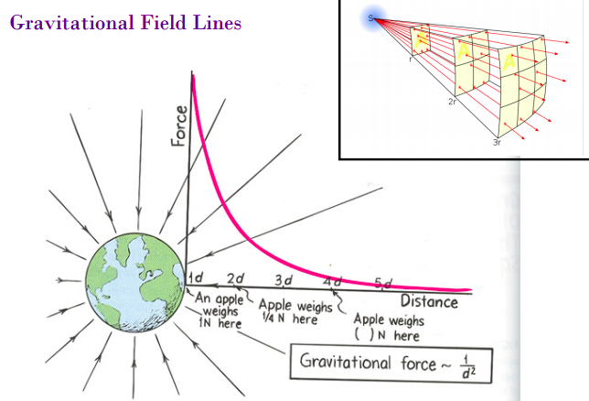
Inverse square law (in the top right corner)

GRAVITATIONAL FIELD STRENGTH
$g=\frac{GM}{r^{2}}$
g = gravitational field strength (N.kg⁻¹)
G = universal gravitational constant (6.67 x 10⁻¹¹ N.m².kg⁻²)
M = mass of object around which the gravitational field spreads (kg)
r = distance from the centre of mass of the object

g = same regardless of direction

SATELLITE MOTION
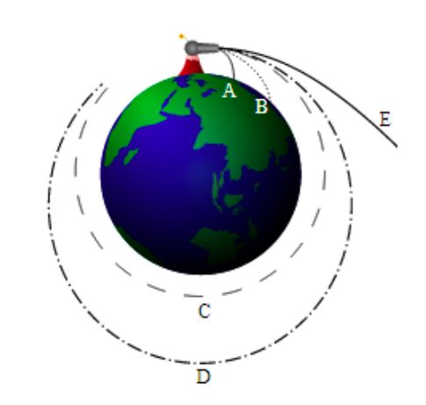
How fast must a satellite be travelling in order to remain orbiting at a particular height?
$F_{c}=F_{g}$
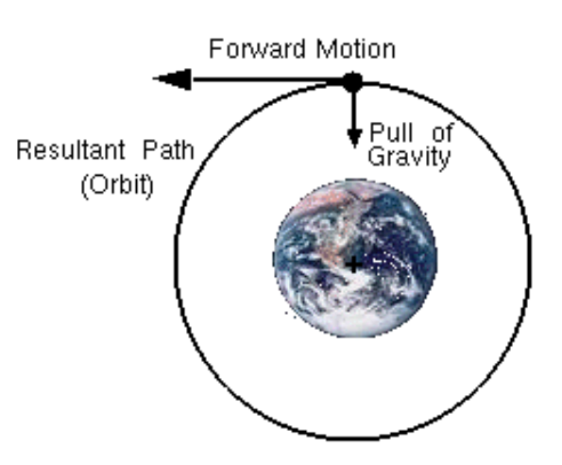
Geosynchronous satellite = stays over the same place on the earth (use F_{c} = F_{g})

KEPLER’S LAWS
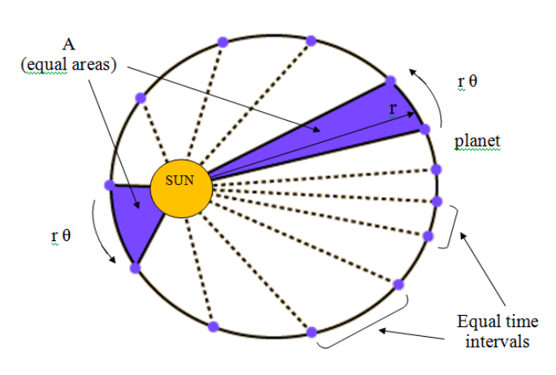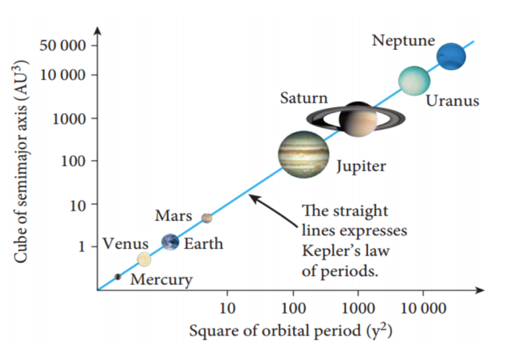
at fastest point = perihelion (blue section on the left), at the slowest point = aphelion (blue section on the right)
Velocity is fastest at the perihelion
Graph: plotting r³ on the y axis and T² on the x axis
There is only a need for Kepler’s 3rd law

TORQUE
WHAT IS TORQUE?
- Turning force
- Also referred to as “moment of a force” (Moments, M)

HOW IS TORQUE MEASURED?
Need to know:
- The magnitude of the applied force
- The direction of the applied force
- The location of the applied force

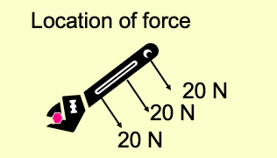
The forces nearer the end of the wrench have greater torques

UNITS FOR TORQUE
$τ=r_{⊥ }F$
$τ$ = torque (Nm)
$r_{⊥ }$= perpendicular distance to the pivot point (m)
F = force (N)
**MUST BE PERPENDICULAR AND IF NOT THEN CALCULATE PERPENDICULAR DISTANCE**

WHEN THE FORCE IS NOT PERPENDICULAR TO THE PIVOT POINT
You need to find the perpendicular distance between the line of force and the pivot. This value will be your r-perpendicular ($r_{⊥}$)
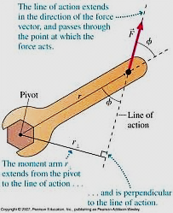
$τ=r_{ }F sinθ$

example:
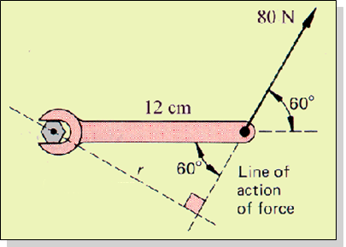
$τ$ = r F sin θ
= (0.12) (80N) (sin (60))
= 8.31 N m

DIRECTION OF TORQUE
Torque is a vector quantity that has direction as well as magnitude
vector x scalar = a vector

Sign convention
- anticlockwise torques are positive
- clockwise torques are negative

Positive torque: Counter-clockwise, out of page
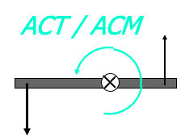

Negative torque: clockwise, into page

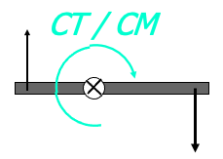

TORQUE AS A VECTOR
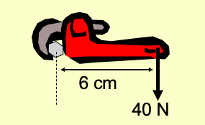
$τ$ = (40 N)(0.060 m)
= 2.40 N⋅m, Clockwise

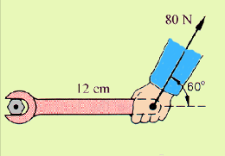
$τ$ = r F sin θ
= (0.12) (80N) (sin (60))
= 8.31 N.m, Anticlockwise

RESULTANT TORQUE
When more than one force is acting on an object, you will have a resultant torque = Σ torques
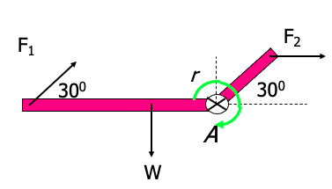

Steps:
① Read, draw, and label a rough figure.
② Draw free-body diagram showing all forces, distances, and axis of rotation.
③ Calculate torques due to EACH individual force affixing proper sign. CCW (+) and CW (-).
④ Resultant torque is sum of individual torques.

Example
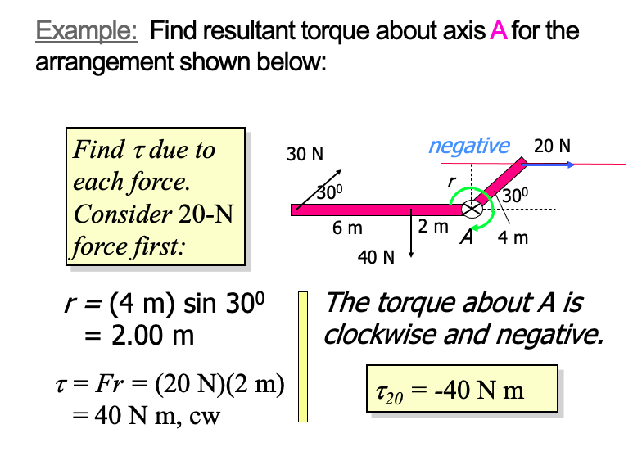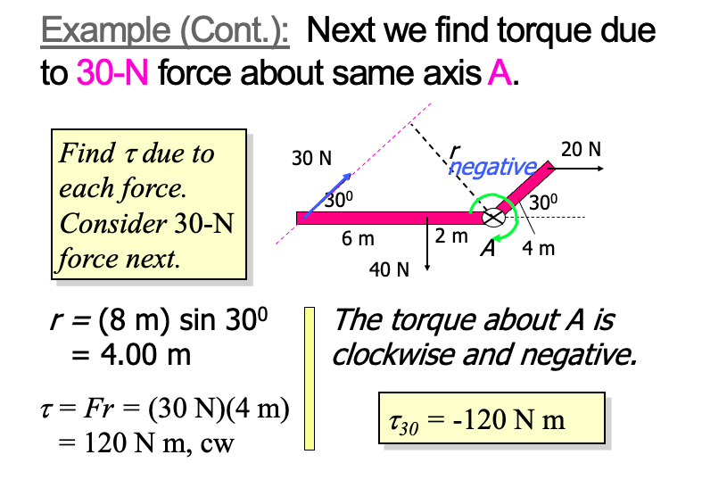
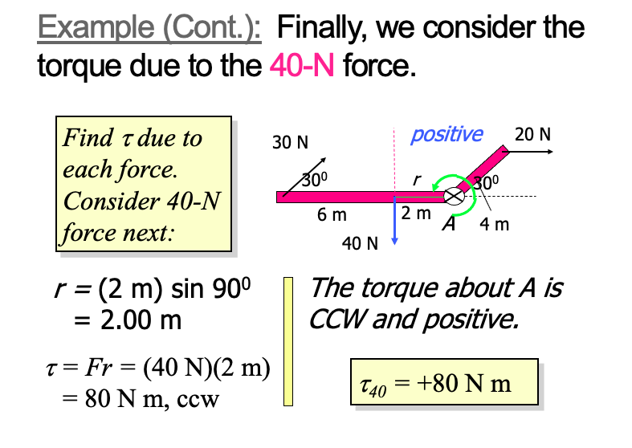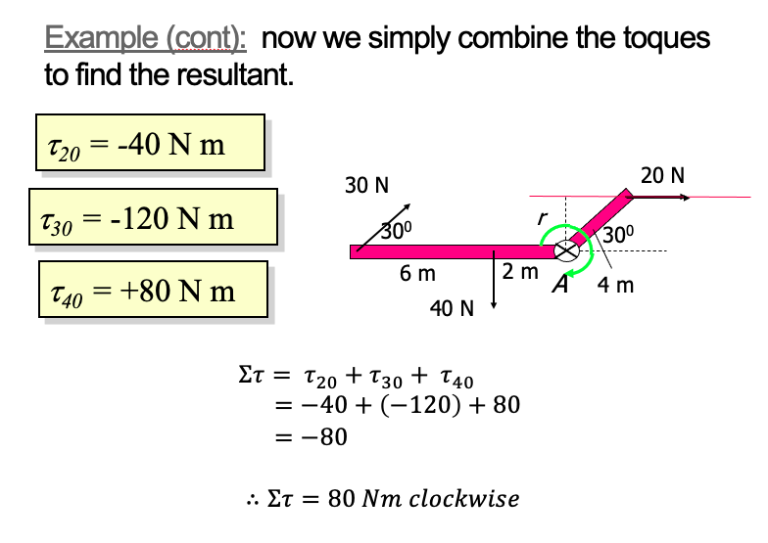

DISEQUILIBRIUM AND EQUILIBRIUM
Disequilibrium
$ΣF≠0$
$ΣM≠0$
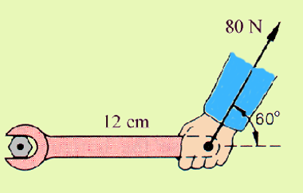

Equilibrium
$ΣF=0$
$ΣM=0 (ΣM_{CW}= ΣM_{ACW}$)
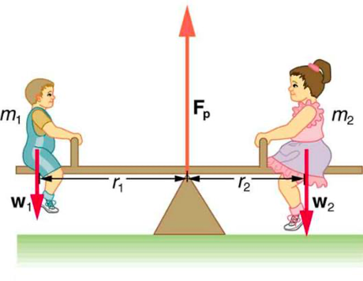

translational equilibrium: ΣF = 0
rotational equilibrium: ΣM = 0
static equilibrium: ΣM = 0 and ΣF = 0
(M = moment of torque)

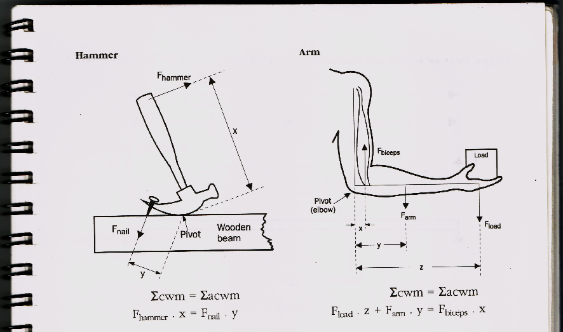

STABILITY
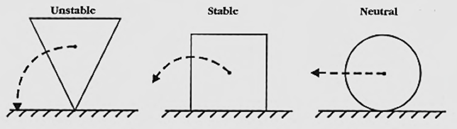
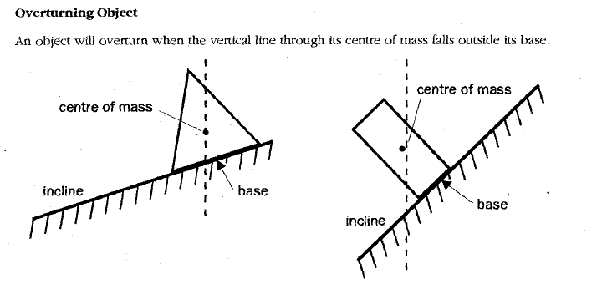
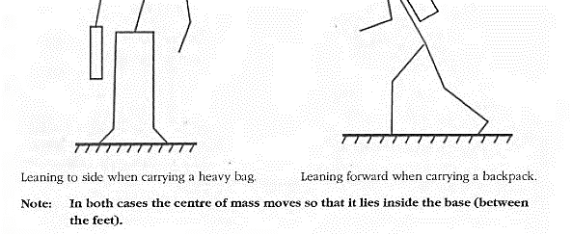
Stable = center of mass (COM) above the base

WHAT FORCE IS REQUIRED TO TIP THE BOX?
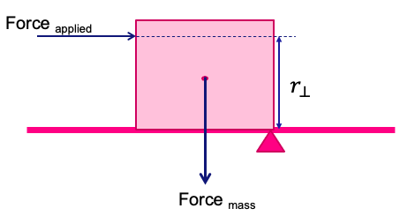
${Στ}_{cw }>{Στ}_{Acw }$
$F_{A }. r_{⊥}> F_{m }. r_{⊥}$

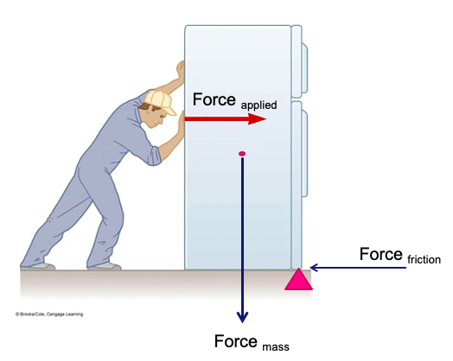
${Στ}_{cw }>{Στ}_{Acw }$
$F_{A }. r_{⊥}> F_{m }. r_{⊥}$ + $F_{f }. r_{⊥}$

FINDING CENTER OF MASS OF A SYSTEM
At the com/cog (center of mass/gravity) the system will be in equilibrium
$ΣF=0 and Στ=0$

Steps:
① Calculate your total downward force of the system. In equilibrium this will equal your total upward force. F_{down} = F_{up}
② Use $Στ=0$ (i.e. $Στ$_{CW} = $Στ$_{ACW}) to determine where the upward force will need to be located (the r value) in order for the F_{up} to balance F_{down} (do this by placing a pivot under one of the masses)

MOBILES
Example
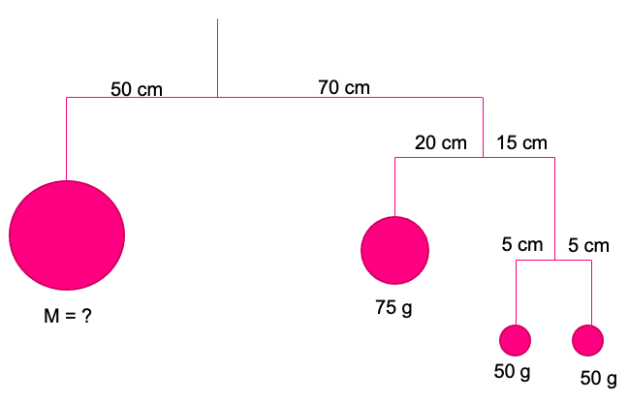
Place pivot in the middle (to ignore tension)
F_{up} = F_{down}

STRUTS AND TIES
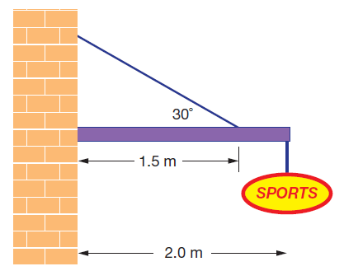
Tension acts up and back the rope
${Στ}_{cw }>{Στ}_{Acw }$
To find the reaction force draw a triangle with the tension and the weight forces and connect with the reaction force arrow

LADDERS – THE BASIC IDEA
- You have a ladder leaning against a wall (usually frictionless)
- The ladder is held in place by the friction between its base and the deck it rests upon
- Required to figure out various things:
  - the angle the ladder makes with the deck
  - the friction force
  - the force exerted on the top of the ladder by the wall, etc.

SOLVING LADDER PROBLEMS
Use the fact that it is in equilibrium, therefore:
ΣF = 0 and Στ = 0

CABLES SUPPORTING A LOAD
Method 1: Equate vertical and horizontal forces (F_{up} = F_{down} and F_{left} = F_{right}) and solve using simultaneous equations
Method 2: Use triangle addition of forces (sine rule) to give a null (zero) vector

ELECTROMAGNETISM

ELECTRIC FIELDS AND FORCES
ELECTRIC FIELDS
- Any charged object has a region around it (an electrical field) where another charged object will experience a force
  - We say that this region of space contains an electric field
- electric fields can exert forces of attraction or repulsion
- An electric field is a vector quantity (has both direction and strength)

ELECTRIC FIELD DIAGRAMS
- Field's direction is given by the direction a positive charge would move in the region
- Closeness of the electric field lines represents the relative strength of the field
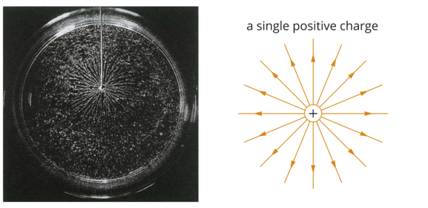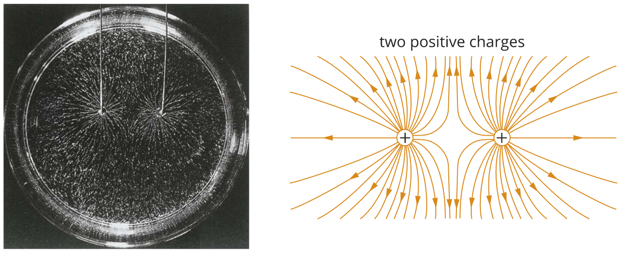
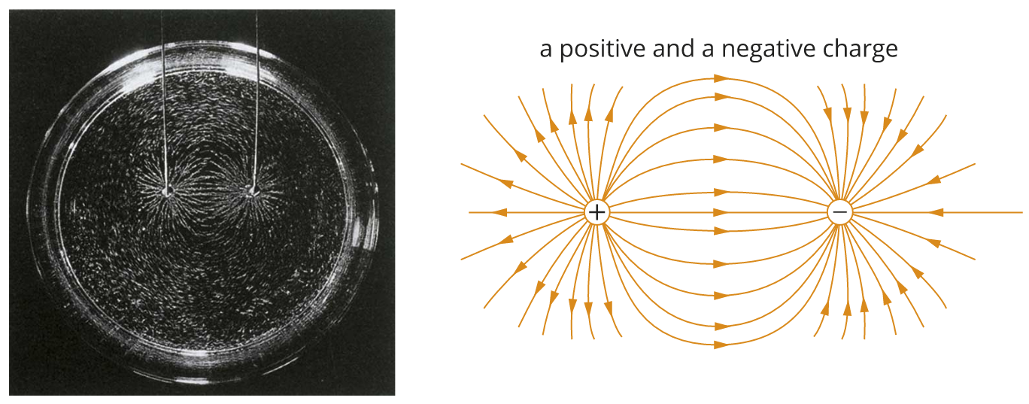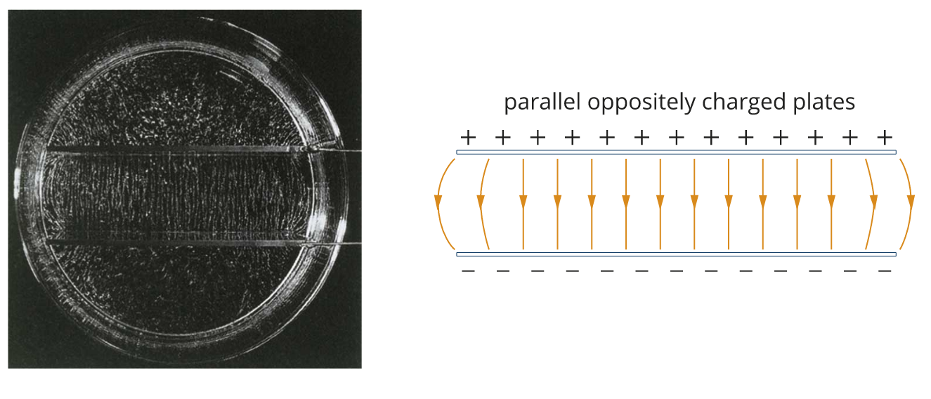

ELECTRIC FIELDS
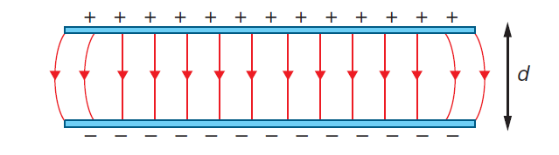
$E=\frac{F}{q}$
F = force (N)
E = electric field (N.C⁻¹)
q = electric charge (C)

between 2 parallel plates can also be written as:
$E=\frac{∆V}{d}$
E = electric field (N.C⁻¹)
$∆$V = potential difference (V)
d = separation between plates (m)

combining the equations
$F=\frac{q∆V}{d}$
$W_{d}=q∆V$
Since $W=∆E$
$∆KE=q∆V$

COULOMBS LAW
$F=\frac{1}{4πε_{0}}\frac{q_{1}q_{2}}{r^{2}}$
$\frac{1}{4πε_{0}}$ = $k$ = Coulomb’s constant = $9 ×{10}^{9} N{.m}^{2}.C^{-2}$
$q$ = electric charge (C)
$ε_{0}$ = electronic constant/permeability of free space (see formula sheet)

MAGNETIC FIELDS AND FORCES
WHAT IS MAGNETISIM?
- Weak force
- Results from the motion of electric charges.
- A spinning electron causes a magnetic field to form around it. In most materials, the magnetic field of one electron is cancelled by an opposite magnetic field produced by the other electron in the pair.
- If electrons spin in the same direction or are not cancelled by another electron = magnetism

MAGNETS
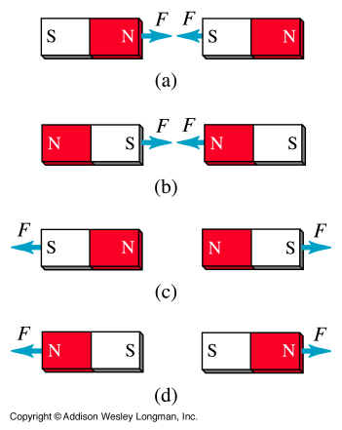
- Magnets have 2 poles (north and south) - dipolar
- Like poles repel
- Unlike poles attract
- Magnets create a MAGNETIC FIELD around them

DOMAINS
A small section of a ferromagnetic material where the atoms in a magnetic field line up
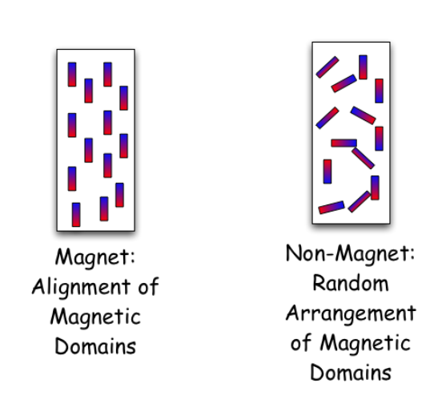

MAGNETIC FIELD
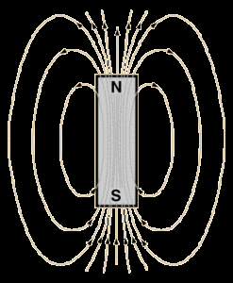

- A bar magnet has a magnetic field around it. This field is 3D in nature and often represented by lines leaving north and entering south
- To define a magnetic field, you need to understand the magnitude and direction
- The letter ‘B’ is the symbol for a magnetic field with Tesla (T) as the unit

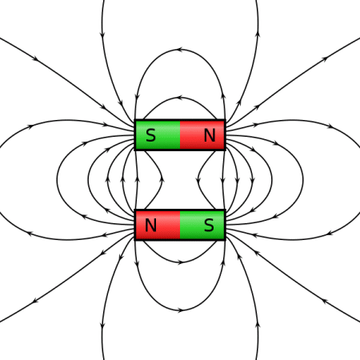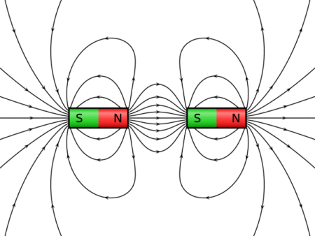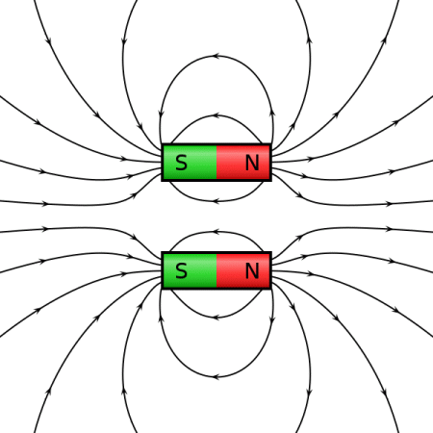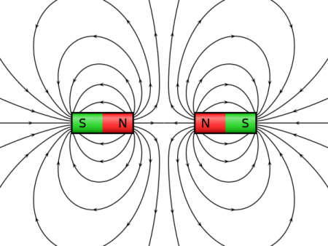

THE EFFECT OF THE EARTH’S MAGNETIC FIELD ON MAGNETS
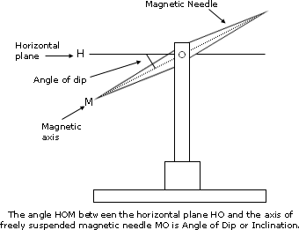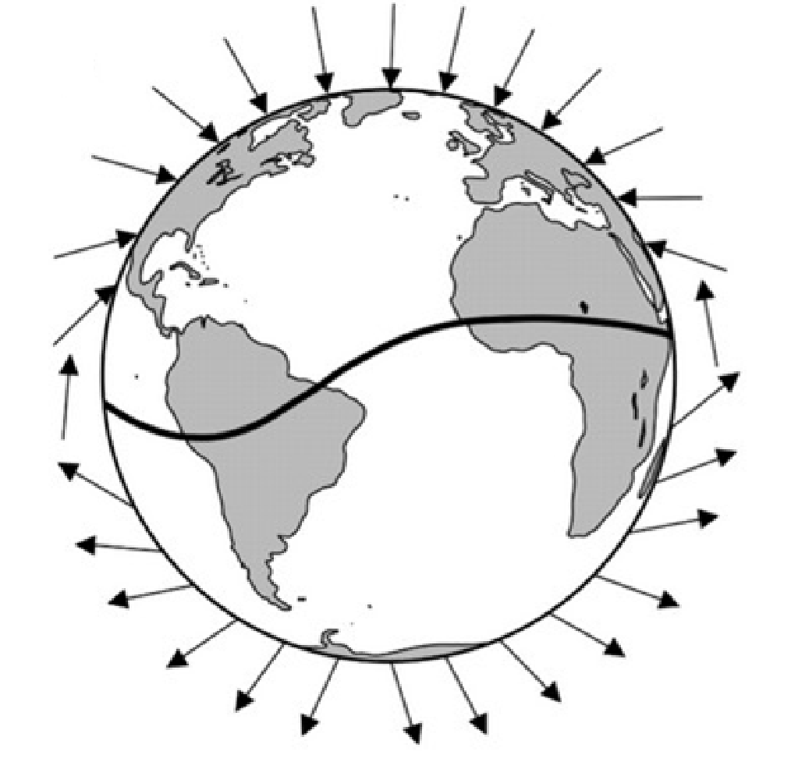

ELECTRIC CURRENT AND MAGNETS
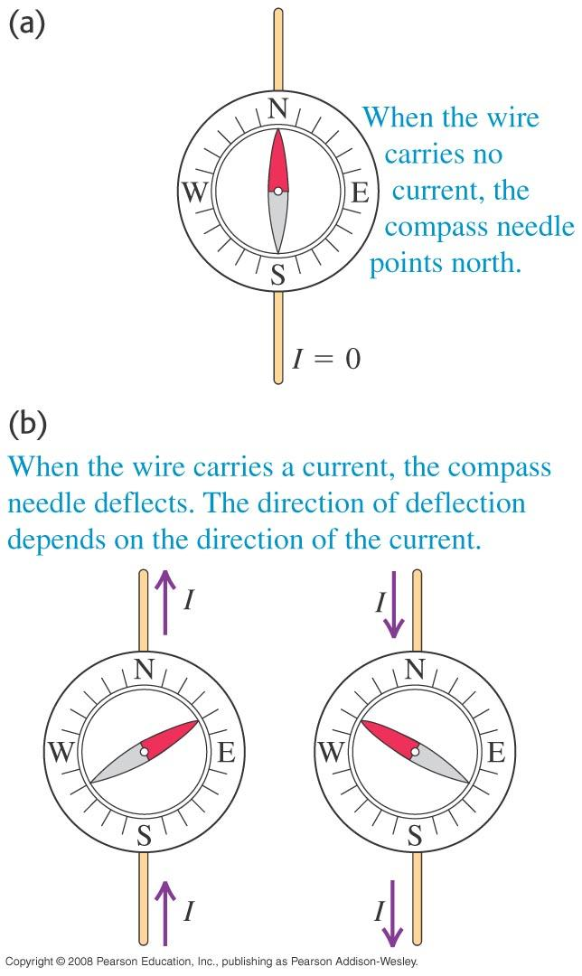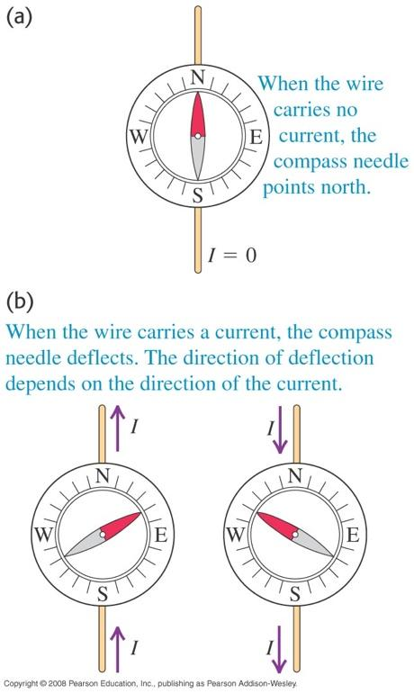

MAGNETIC FIELDS DUE TO ELECTRIC CURRENTS: WHY DOES THE WIRE MOVE?
The real question is WHY does the wire move? It is easy to say the EXTERNAL field moved it. But how can an external magnetic field FORCE the wire to move in a certain direction?
THE WIRE ITSELF MUST BE MAGNETIC!!! In other words the wire has its own INTERNAL MAGNETIC FIELD that is attracted or repulsed by the EXTERNAL FIELD.

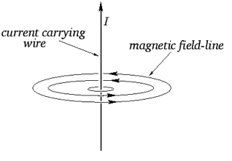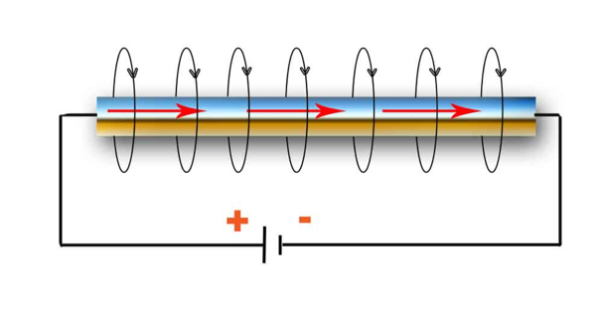
$B↓with \frac{1}{r^{2}}$
As it turns out, the wire’s OWN internal magnetic field makes concentric circles round the wire.

DIRECTION OF THE MAGNETIC FIELD? RIGHT HAND GRIP RULE
To figure out the DIRECTION of this INTERNAL field you use the right hand rule. You point your thumb in the direction of the current then CURL your fingers. Your fingers will point in the direction of the magnetic field
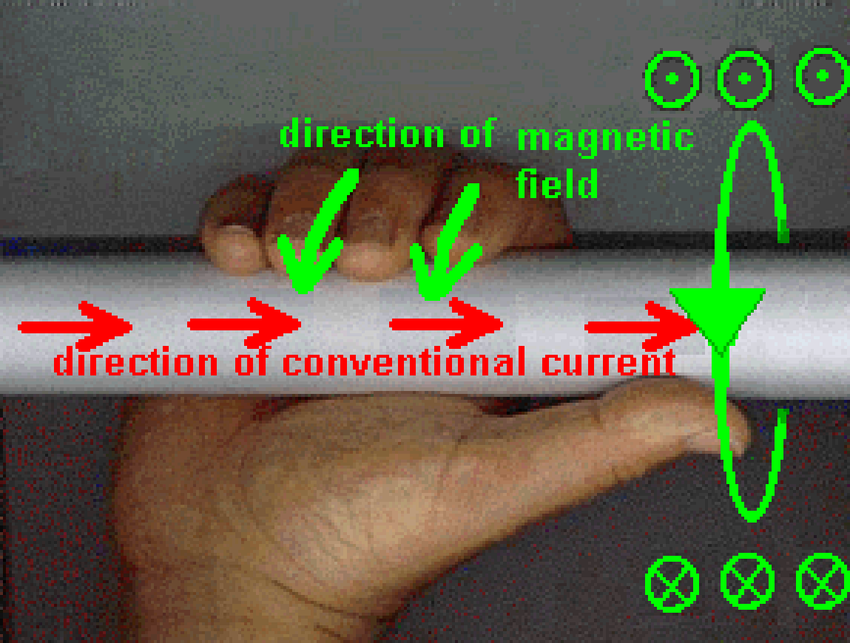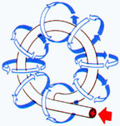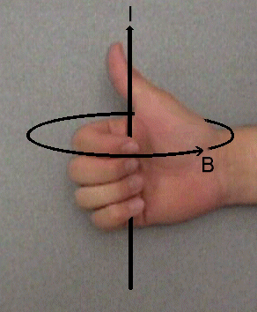

MAGNETIC FIELD CAUSED BY A STRAIGHT CURRENT-CARRY WIRE
$B=\frac{μ_{0}I}{2πr}$
B = magnetic field (T)
I = current (A)
r = distance from wire
$μ_{0}$ = permeability of free space

MAGNETIC FIELD IN LOOPS (COILS/SOLENOIDS)
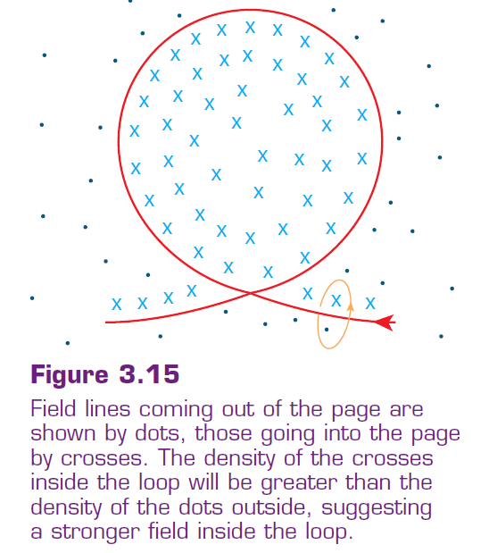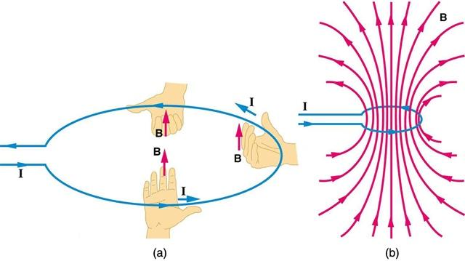
Note: always grip the coil such that your fingers go through the centre of the coil.
The current is in the opposite direction in both images, hence the magnetic field points in opposite directions.

SOLENOIDS AS ELECTROMAGNETS
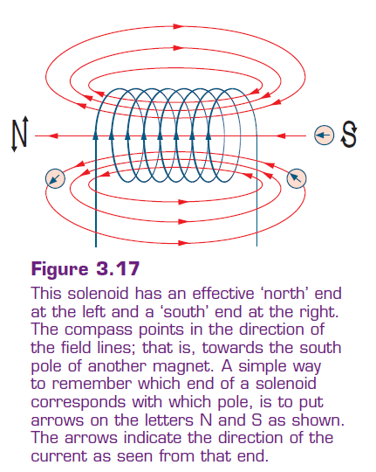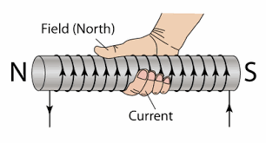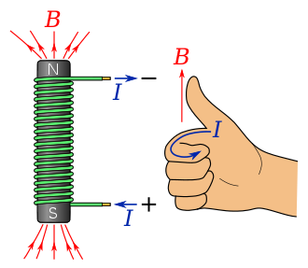

MAGNETIC FIELDS CREATED BY CURRENTS MOVING IN LOOP WIRES
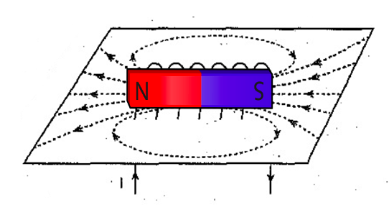

DIRECTION OF THE MAGNETIC FORCE? RIGHT HAND RULE
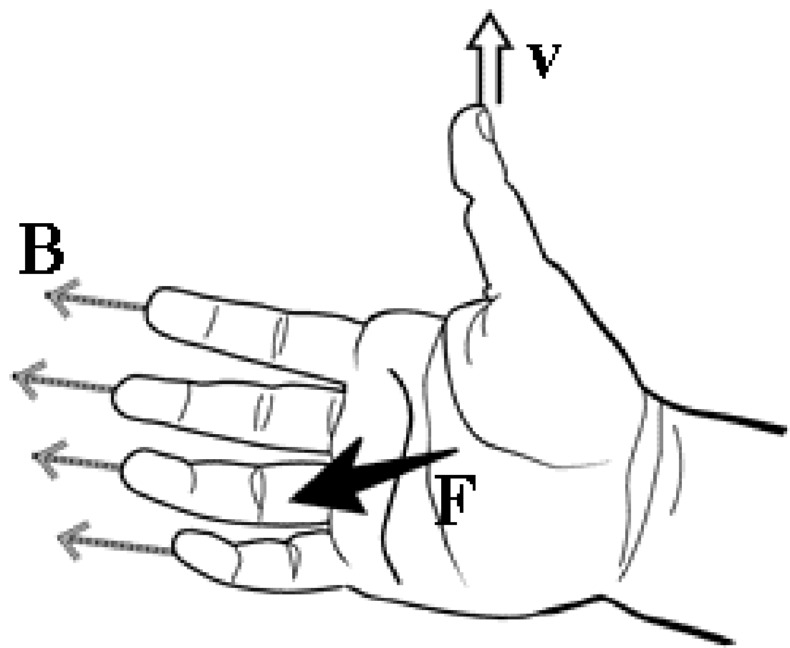
- The Fingers = Direction B-Field
- The Thumb = Direction of velocity
- The Palm = Direction of the Force

Basically you hold your right hand flat with your thumb perpendicular to the rest of your fingers
To determine the DIRECTION of the force on a POSITIVE charge we use a special technique that helps us understand the 3D/perpendicular nature of magnetic fields.
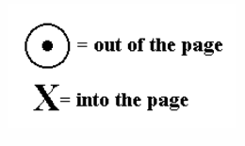
For NEGATIVE charges use left hand!
The magnetic field used here is an external magnetic field. It is not the field created by the current itself!

THE MAGNETIC FORCE ON A MOVING CHARGE
- The magnetic force on a moving charge q is perpendicular to both:
  - The velocity vector direction of q
  - The magnetic field
- The magnitude of the magnetic force is $F=qvB$
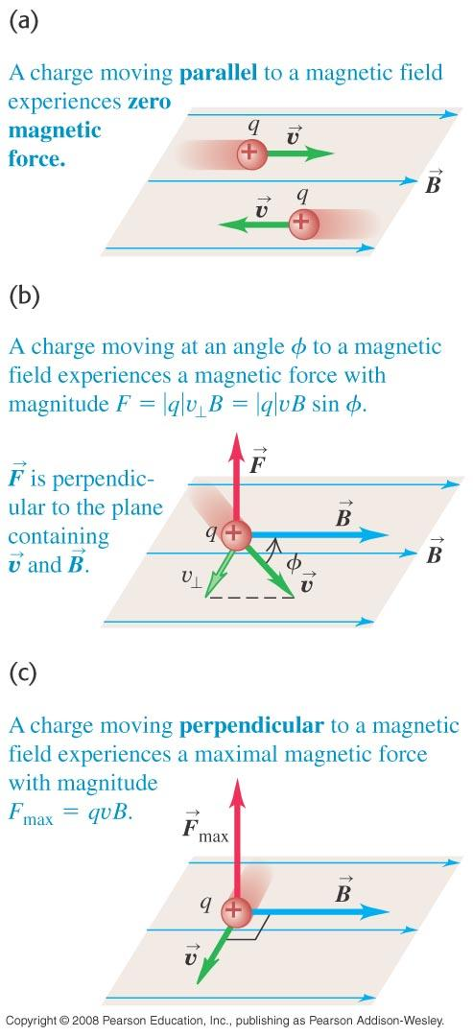

MAGNETIC FORCE AND CIRCULAR MOTION
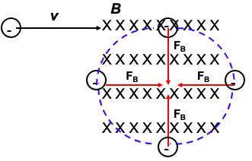
Suppose we have an electron traveling at a velocity , v, entering a magnetic field, B, directed into the page. What happens after the initial force acts on the charge?
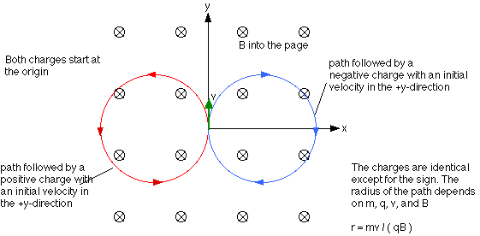

$F_{B}=qvB$ and $F_{c}=\frac{mv^{2}}{r}$
$F_{B}=F_{c}$
$qvB=\frac{mv^{2}}{r}$
$r=\frac{mv}{qB}$
The magnetic force is equal to the centripetal force and thus can be used to solve for the circular path.
Or, if the radius is known, could be used to solve for the MASS of the ion. This could be used to determine the material of the object.

FORCE DUE TO CHARGES MOVING IN A WIRE
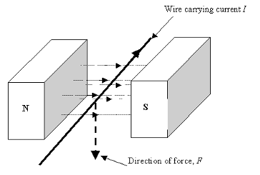
You simply used the RIGHT HAND ONLY and the thumb will represent the direction of the CURRENT instead of the velocity.

$F_{B}=qvBsinθ×\frac{t}{t}$
$F_{B}=\left(\frac{q}{t}\right)\left(vt\right)Bsinθ$
$F_{B}=IlBsinθ$
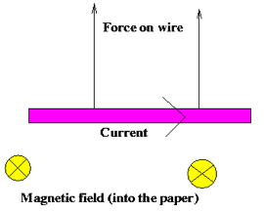

THE MOTOR EFFECT
AN ELECTRICAL MOTOR
- converts electrical energy to mechanical energy
  - The mechanical energy is in the form of rotational kinetic energy
- consists of a rigid current-carrying loop that rotates when placed in a magnetic field (created by a permanent magnet or electromagnet)
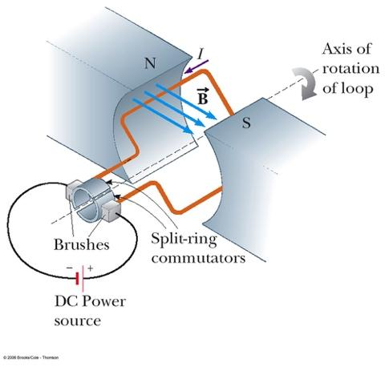

How it works
- The current direction on one side of the coil is opposite to the current direction on the other side.
- One force (F) is upwards on the right and one force (F) downwards on the left.
- This produces a rotating torque on the coil.
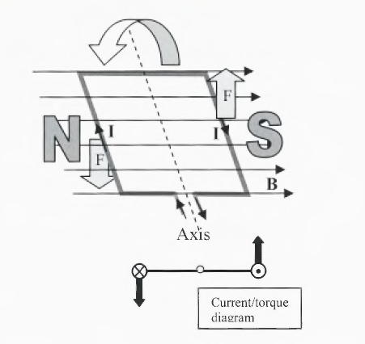

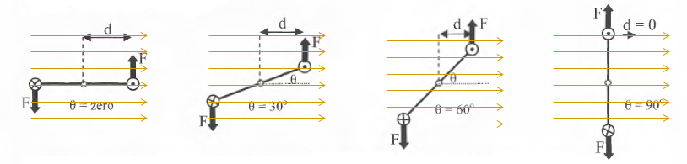
The perpendicular distance (d) between the force ($F=IlB$) and the pivot becomes less with angle. Thus the torque is a maximum at 0° and zero at 90°

The graph of torque versus angle is shown below:
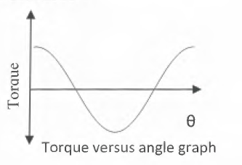

MAGNETIC FIELD AROUND THE COIL IN A MOTOR
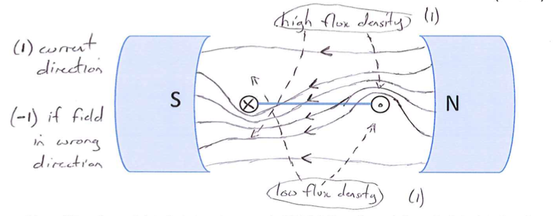

NOTE: THE EFFECT OF THE BRUSHES ON THE SPLIT RING (COMMUTATOR)
When the plane of the rotating coil reaches horizontal, the brushes will break contact (not much is lost, because this is the point of zero torque anyway – the forces act outward). The angular momentum of the coil carries it past this break point and the current then flows in the opposite direction, which reverses the magnetic dipole. So, after passing the break point, the rotor continues to turn anticlockwise and starts to align in the opposite direction.

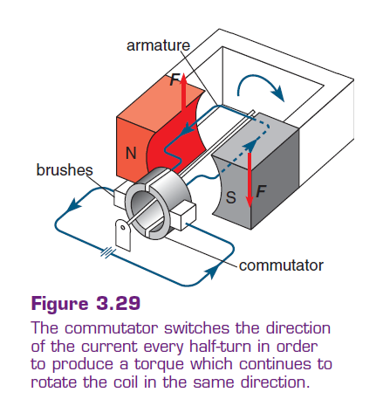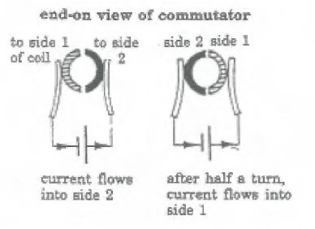

A COIL MADE OF MORE THAN ONE LOOP
If there is more than one turn on the coil (N) then the force on each side is found by:
$F=NIlB$

ELECTROMAGNETIC INDUCTION AND FARADAY’S LAWS
So, electric currents produce (and respond to) magnetic fields, or, more generally,


What about the reverse? Can magnetic fields produce electric currents? Or, more generally,


Our suspicion from our magnetism unit about the deep connection between electricity and magnetism says the answer must be “yes!”

WHAT IS ELECTROMAGNETIC INDUCTION
Electromagnetic Induction is the process of using magnetic fields to produce voltage (or Electro Motive Force, emf), which in a complete circuit, creates a current.

Michael Faraday first discovered it. His work started at first using different combinations of wires and magnetic strengths and constant currents but met no success. What he did observe was that the galvanometer deflected strongly at the moment he closed the switch, and deflected strongly again, in the opposite direction, when he opened the switch, but a constant current produced a constant magnetic field which produced no current and no deflection in the galvanometer.
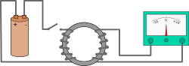
It turns out that electromagnetic induction is only created with a changing magnetic field.

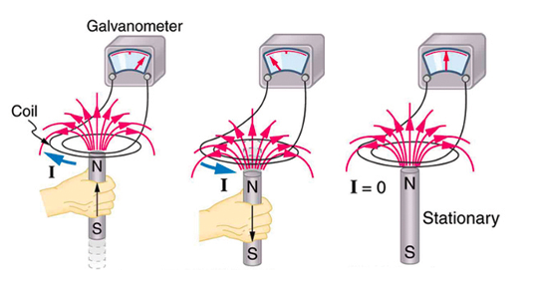
- A current is induced when a magnet is moved toward a coil, momentarily increasing the magnetic field through the coil.
- The induced current is in the opposite direction when the magnet is moved away from the coil (B decreases).
- No current is induced as the magnet does not move relative to the coil.

MAGNETIC FLUX
$∅=BA$
$∅$ = magnetic flux passing through the coil (Wb – Weber)
B = magnetic flux density (T)
A = area of the coil perpendicular to the direction of the magnetic field (m²)
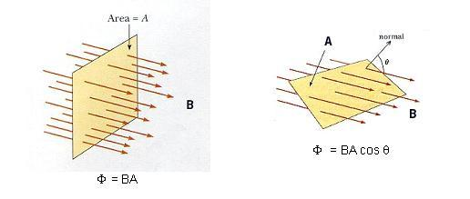
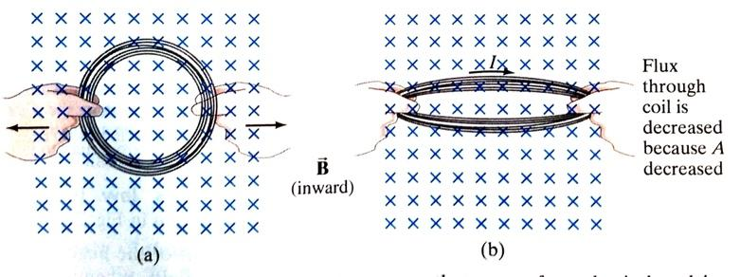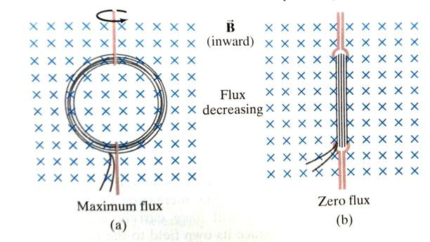

FARADAY’S LAW OF INDUCTION
Faraday learned that if you change any part of the flux over time you could induce a current in a conductor and thus create a source of EMF (voltage, potential difference). Since we are dealing with time here were a talking about the RATE of CHANGE of FLUX, which is called Faraday’s Law.
$ε=-N\frac{∆∅}{∆t}$
$ε=-N\frac{∆(BAcosθ)}{∆t}$
N = number of turns on the wire
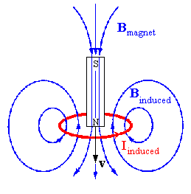

LENZ’S LAW
- The minus sign in Faraday’s law of induction is there to remind us in which direction the induced emf acts. Experiments show that:
- a current produced by an induced emf moves in a direction so that its magnetic field opposes the original change in flux.
- Thus the minus sign indicates that the induced emf and the change in flux have opposite signs as they act in opposite directions.

DETERMINING DIRECTION OF INDUCED CURRENT USING LENZ’S LAW

Finding current with RHR.
↑B = I must form a B inside the loop that opposes the external B.
↓B = I must form a B inside the loop that points in the same direction as the external B (you want to oppose B, the opposite of a decreasing mag field is an increasing one, therefore to increase it you want the B lines to point in the same direction).

LENZ’S LAW & FARADAY’S LAW
$ε=-N\frac{∆∅}{∆t}$
This means that the INDUCED MAGNETIC FIELD around the WIRE caused by the moving magnet OPPOSES the original magnetic field. Since the original B field is downward, the induced field is upward! We can then use the left-hand grip rule to determine the direction of the current.
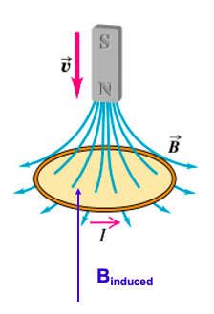

EDDY CURRENTS
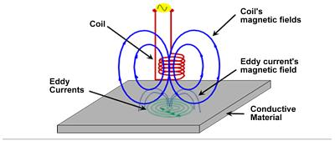
Eddy currents are loops of electrical current induced within conductors by a changing magnetic field in the conductor, due to Faraday's law of induction. Eddy currents flow in closed loops within conductors, in planes perpendicular to the magnetic field.



EMF INDUCED IN A MOVING CONDUCTOR
Suppose a bar of length, L, is pulled to right at a speed, v, in a magnetic field, B, directed into the page. The conducting rod itself completes a circuit across a set of parallel conducting rails with a resistor mounted between them.

$ε=-N\frac{∆∅}{∆t}$
$ε=\frac{B∆A}{t}→\frac{Bl∆x}{t}$
$ε=Blv$

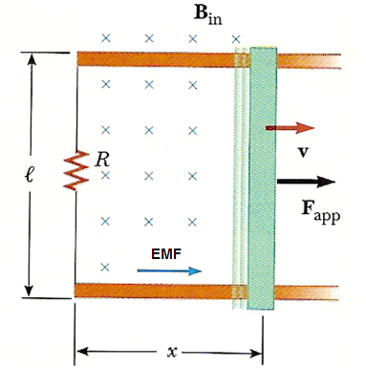
In the figure, we are applying a force this time to the rod. Due to Lenz’s Law the magnetic force opposes the applied force. Since we know that the magnetic field acts into the page, we can use the LHR to determine the direction of the emf (current) around the loop and the resistor.

IN SUMMARY
Faraday’s Law is basically used to find the MAGNITUDE of the induced EMF. The magnitude of the current can then be found using Ohm’s Law provided we know the conductor’s resistance.
Lenz’s Law is part of Faraday’s Law and can help you determine the direction of the current provided you know HOW the flux is changing.

LENZ’S LAW, BACK EMF AND MOTORS
- When the coil of a motor is turned, magnetic flux changes, and an electromotive force (EMF), consistent with Faraday's law of induction, is induced.
- Lenz’s law tells us the induced EMF opposes any change, so that the input EMF that powers the motor will be opposed by the motor's self-generated EMF, called the back EMF of the motor.
- As well as acting against the applied voltage that's causing the motor to spin in the first place, back EMF also reduces the current flowing through the coils of the motor (remember V=IR, reducing the net V will reduce I).

GENERATORS – AC AND DC
AC GENERATORS
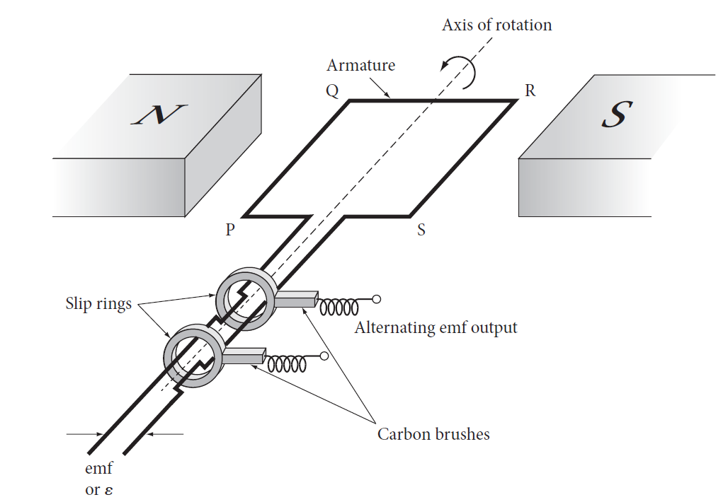

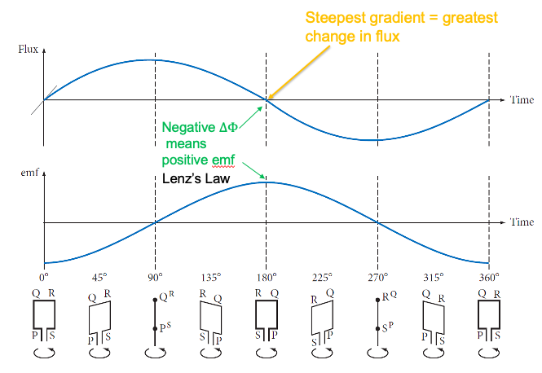

PHASE POWER
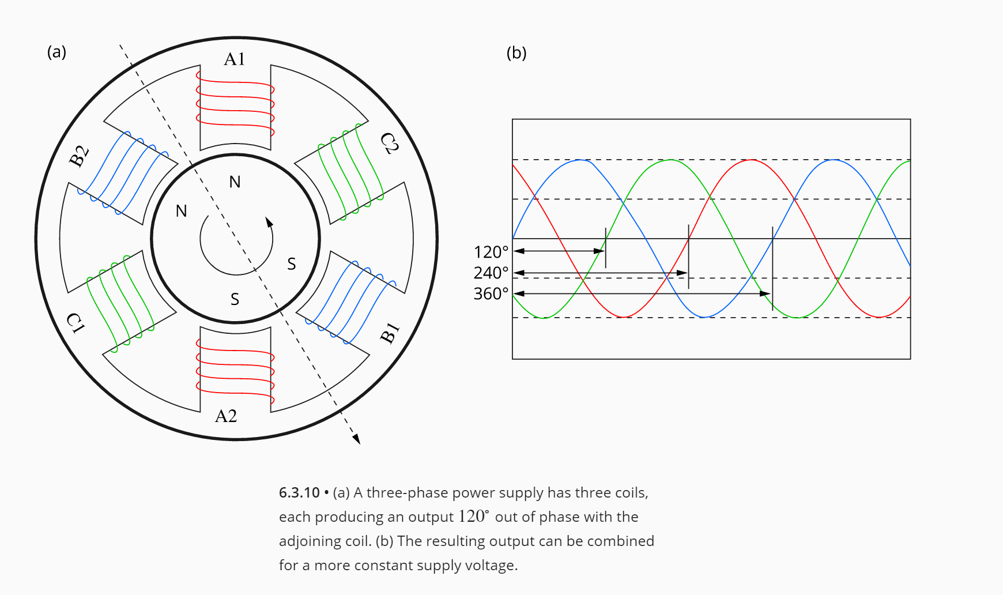

DC GENERATOR
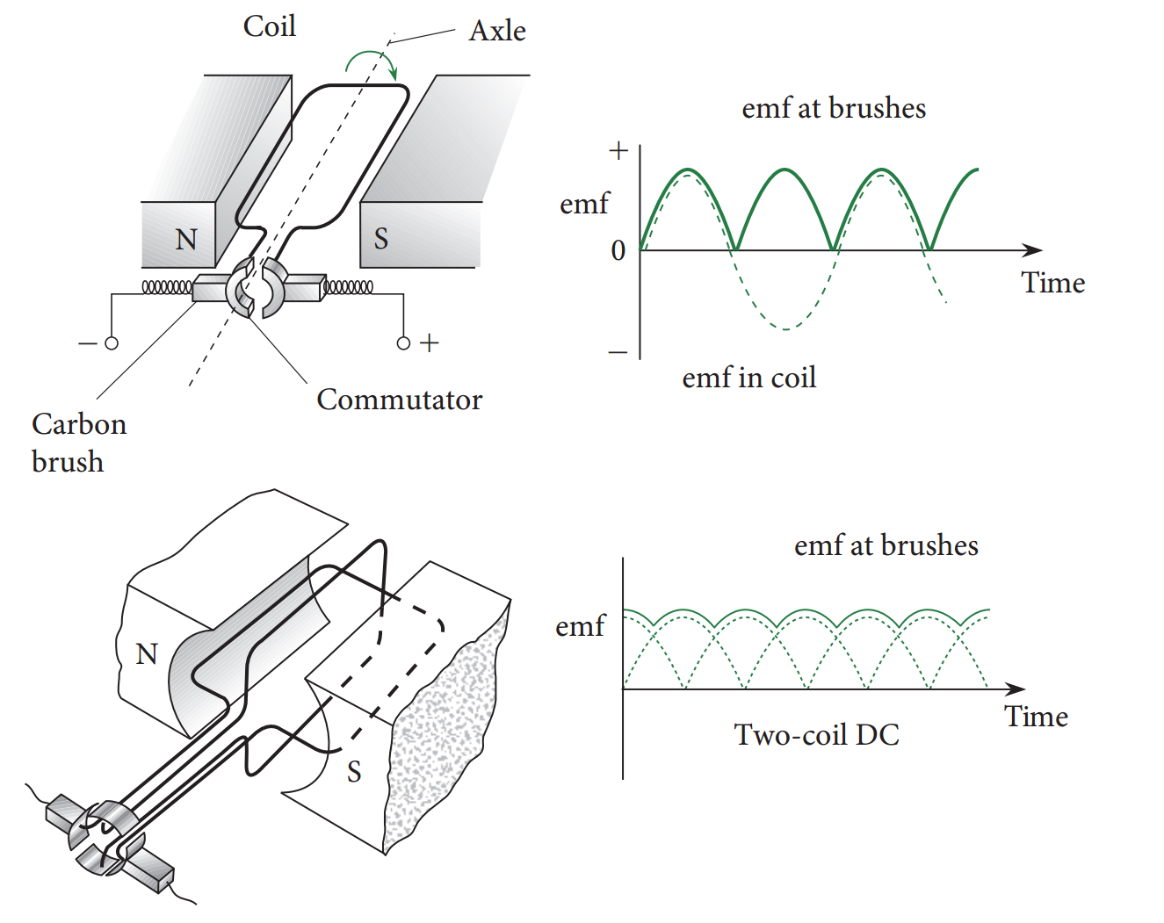
- split-ring commutator reverses current direction
- results in ‘lumpy’ emf, time-varying DC (always positive)
- Multiple coils reduce ‘lumpiness’

BACK EMF AND MOTOR
- The back EMF, following Lenz's law, opposes the magnetic field that created it, so the induced EMF will be in the opposite direction to the EMF creating it.
- When the motor reaches its maximum operating speed back emf will be generated at a constant rate.
- When a load is applied, the speed of the motor is reduced, which reduces the back emf and hence increases current in the motor. If the load stops the motor from moving then the current may be high enough to burn out the motor coil windings.
- Generally, the load slows the armature down and so the current increases as the back emf is decreased. This produces an increase in current and torque to cope with the increased load.

AC GENERATORS AND AVERAGE EMF
An average is, in general, the one value that best represents a set of values. For AC analysis, the average is not the middle point (as this would be zero for an AC generator) but is taken as the root-mean-square value (rms). It is the equivalent constant DC quantity that delivers the same power as the sinusoidally varying AC quantity.
$ε_{rms}=\frac{1}{\sqrt{2}}ε_{max}$
$ε_{rms}=\sqrt{2}πfnBA$

$I_{rms}=\frac{1}{\sqrt{2}}I_{max}$
$I_{rms}=\frac{\sqrt{2}πfnBA}{R}$

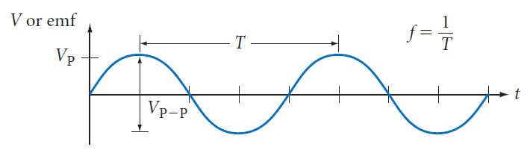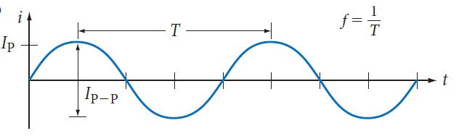

POWER TRANSMISSION
TRANSMISSION LINES AND POWER LOSS
Power plants are often situated some distance from metropolitan areas, so electricity must be transmitted over long distances. There is always some power loss in the transmission lines, and this loss can be minimised if the power is transmitted at high voltages, using transformers.
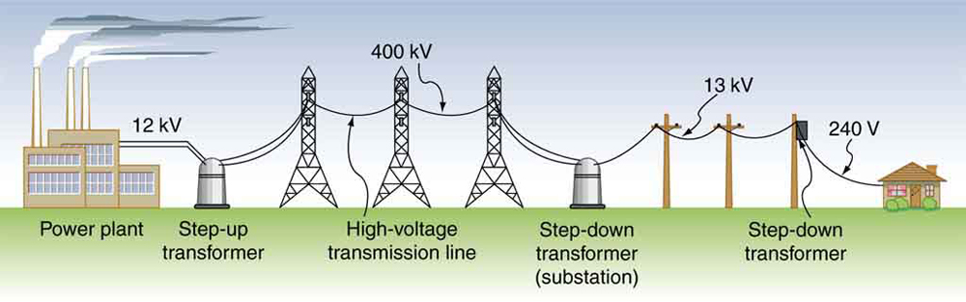

POWER LOSS IN TRANSMISSION LINES
We see that P_{L} $∝$ I² and as V $∝$ I a higher voltage results in less current, and thus less power is wasted as heat in the transmission lines

TRANSFORMERS
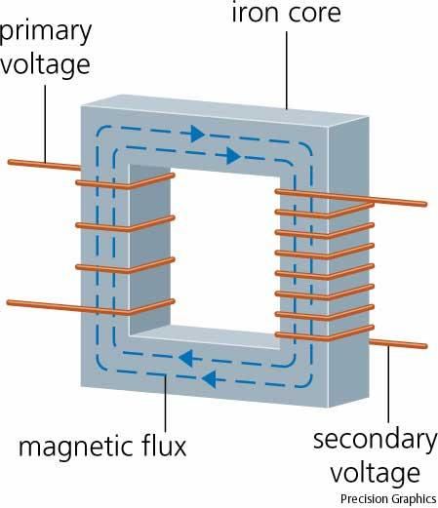
WHAT ARE TRANSFORMERS?
- A device used for increasing or decreasing AC voltage
- Consists of 2 coils of wire known as the primary and secondary coils
- Designed so all the $∅$ produced by the change in the primary coil also passes through the secondary coil

HOW THEY WORK
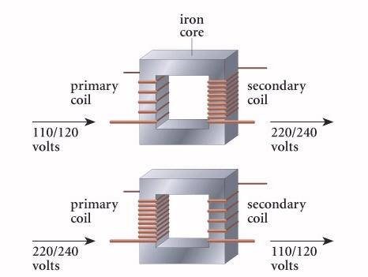
- When an AC voltage is applied to the primary loop, the current produced moves quickly BACK and FORTH through the primary coil creating a changing magnetic field.
- This changing magnetic field will induce an AC voltage of the same frequency in the secondary loop. However the voltage will be different according to the number of loops in each coil.

If the secondary coil has MORE turns than the primary you can step up the voltage and runs devices that would normally need MORE voltage than what you have coming in. We call this a STEP UP transformer.
We can use this idea in reverse as well to create a STEP DOWN transformer.
*Relates to the Area: ↑A = step up, ↓ A = step down

TRANSFORMERS EQUATIONS
Voltage in primary coil: $V_{p}=N_{p}\frac{∆∅B}{t}$
Voltage in the secondary coil: $V_{s}=N_{s}\frac{∆∅B}{t}$
Ratio of the voltage to the number of turns in the coil:
$\frac{V_{s}}{V_{p}}=\frac{N_{s}}{N_{p}}$

Due to energy conservation, power output cannot be greater than power input. The power output for a 100% efficient system is therefore equal to the input since $P=VI$
$I_{p}V_{p}=I_{s}V_{s}$
$\frac{I_{s}}{I_{p}}=\frac{N_{p}}{N_{s}}$

~~*NOTES FROM BOOKLETS*~~

ELECTROMAGNETISM
- Ferromagnetic materials can be used to see field lines (iron, cobalt, nickel)
  - Magnetic because they have 4-5 more up-spin electrons than down-spins ones (so individual atoms end up with N and S poles)
- Closer field lines = stronger field
- Field lines ALWAYS leave north and enter south
- $B∝\frac{1}{r}$ only applies to a magnetic field around a wire
- $μ$ represents how easily a magnetic field passes through a material, $μ_{0}$ is used for vacuums and air, all other materials will have a different $μ$ value
- X = flow into the page, • = flow out of page
- Unit charge applies to protons and electrons only
  - An ion is a point charge
- $F=\frac{1}{4πε_{0}}\frac{q_{1}q_{2}}{r^{2}}$ is only for point charges
- $E=\frac{V}{d}$ cannot be used to point charges
- Motion of a point charge inside an electric field = always the direction a positive charge will move in
  - Positive point charge moves in direction of the electric field
  - Negative point charge moves in the opposite direction of the electric field
- Positive F = attraction, negative F = repulsion
- When the current is parallel to B, no force is created
- $I=\frac{q}{t}$ is used for moving charges in a magnetic field
- You can use the same equation for a moving charge as you can for a wire ($F=qvB$) because charged particles are moving through a wire, the only difference is that now the charges are not forced to move in a straight line through a wire, they are free to curve in their pathway
- B must be at a 90-degree angle to the velocity to have pure circular motion, velocity at an angle to the field will result in a spiral motion
- A continuous loop will always generate a current that creates a magnetic field that slow the velocity of the magnet and reduces the change in flux
- Changing magnetic field -> potential difference that causes a current to flow in a second coil
- B = how close the field lines are
- Flux = how many field lines are passing through an area
- Ways to induce EMF:
  - Moving a magnet towards a cell
  - Rotating a coil in a magnetic field
  - A stationary coil experiencing a change in magnetic field strength due to turning on and off the DC to an electromagnet above it (or supplying AC current)
  - Moving a wire through a uniform magnetic field
- Induced EMF = separation of charge
- Faraday’s law only works for loops
- Lenz’s law = a current will be created which will create a magnetic field which opposes the motion of the magnet (reduces change in flux)
- Eddy currents = circular currents that form in current conducting tubes, solid sheets of metal. It forms when a material experiences a change in flux or change in B
  - Laminations = smaller eddy currents = less losses

 | Faraday’s Law | Lenz’s Law
Similarities | - Both are initiated due to a change in flux or change in B  - Require a current conducting material
Differences | - The change in flux induces EMF  - Doesn’t discuss current but current could be formed if the EMF forms in a complete circuit  - The EMF can still be created even if the circuit is not closed | - The conducting material must be in a closed circuit  - An eddy current is induced that will create a magnetic field that slows the change in flux

- Cutting through magnetic field lines creates a change in flux
- Generators: mechanical energy -> kinetic energy -> electric energy
  - Always caused by some mechanical action
  - Modern generators involve the rotation of a magnet inside a coil
- AC = 2 slip rings, graph goes above and below x axis
- DC = split ring, graph goes only above the x axis
- Galvanometer measures current
- Slowing motion down, use Lenz’s law
- The primary coil in a transformer has AC voltage connected to it
  - DC wouldn’t work because once the magnetic field is established in the primary coil, there will no longer be a change in flux
- Transformers – the primary coil creates a magnetic field that is carried/transferred to the secondary coil via the iron core – this contains domains that align with the magnetic field produced by the primary coil and ensures that B is maintained as it is transferred to the secondary coil
- Flux linkage – is caused by the iron core and ensures flux is transferred properly
- More turns on the coil = V increases
- Step up = low -> high, step down = high -> low
- Back EMF only occurs in the primary coil of a transformer, which has voltage supplied to it, as soon as current flows in the primary coil a change in B and therefore a change in flux occurs which creates back EMF that reduces voltage overall, slows current (I) therefore slowing the change in flux
- Back EMF in motors = since a motor has a current conducting wire rotating in a magnetic field. It is able to generate EMF which is in the opposite direction to the supplied EMF therefore lowering the overall voltage to the motor
  - When it gets jammed, no back EMF is created since the motor is not turning, therefore the wiring receives the full supply voltage causing and increase in I and melting wiring and components
- The motor principle = when a current flows through a wire, it creates a magnetic field around the wire which interacts with the pre-existing magnetic field to create a force that pushes the wire (turning the motor)
- Motor – current is supplied, turn something
- Generator – turned to make current, in a magnetic field
- Max torque is when F is perpendicular to r
- Split ring commutator – it changes the direction of the current in the armature ensuring the wire next to the north pole is always in the same direction
- Curved magnets cause the magnetic field to be warped such that the force remains perpendicular to r
- The piece of iron has domains that can align with the magnetic field generated by the coil creating an electromagnet, strengthening B, causing a large interaction between magnetic fields and a larger F on the armature
- Circular motion occurs in a magnetic field since the magnetic force is always at 90 degrees to the velocity
- Projectile motion occurs in an electric field since F is always in the same direction relative to the velocity

THE NATURE OF LIGHT
- The scientific model = a theory, tries to explain why something occurs and tries to explain how different factors cause an outcome
- Electromagnetic radiation – electric waves are transverse waves that move at 90 degrees to magnetic waves
- Sound is faster in solids (more particles)
- Light is faster in air (more electrons interfere since its electromagnetic waves)
- Black body radiation – a true black body absorbs all wavelengths of light and their energy is contained within that black body. Most black bodies as they are heated emit some light, the hotter the object is, the shorter the wavelength of light emitted = increase in freq.
- Photoelectric effect – this effect involves using different wavelengths of light to cause an outer valence electron to be ejected (ionisation). It was discovered that lower frequency (higher wavelength) would not eject an electron even after long exposure that should provide sufficient energy. Instead, a minimum f was required and caused instantaneous ejection
  - A photon of light strikes a valence electron transferring all it’s energy to the electron, the energy is used to ionize the electron and any extra energy goes into the KE of the electron
  - Photoelectron – an electron that got ejected from a metal due to photons striking the surface of that metal
  - Photoelectric current – photoelectrons can flow through the vacuum tube from the cathode to the anode, this flow of negative charge creates a current
- By reversing the battery, we have a negative voltage in the set up the cathode (metal where electrons are ejected) is now positively charged. This attracts photoelectrons that were ejected back to the cathode, so they never reach the anode and photoelectric current reduces as negative v increases until the photoelectric voltage = 0A, this is the stopping voltage
- E_{photons} = E_{threshold} + KE
- As the frequency of the incident light increases, the maximum KE of the photoelectrons increases linearly therefore the stopping voltage will increase since KE_{max} = stopping voltage eV (not electron volts, e times V)
- Work function – measure of the amount of energy needed to ionize a surface electron with no KE, different work functions will shift stopping voltages
- W is a measure of the energy needed to ionize (eject) and election with 0 KE
- Threshold frequency = the minimum f needed to eject a surface electron with no KE

WAVE PARTICLE DUALITY AND THE QUANTUM THEORY

WAVE PARTICLE DUALITY

Phenomenon | Wave Theory | Corpuscular Theory
Reflection | ✔ | ✔
Refraction | ✔ | ✔
Interference | ✔ | -
Diffraction | ✔ | -
Polarisation | ✔ | -
Photoelectric effect | - | ✔
Dispersion | - | -

EVIDENCE FOR THE WAVE NATURE OF LIGHT
(reflection, refraction, interference, diffraction, dispersion, polarization)
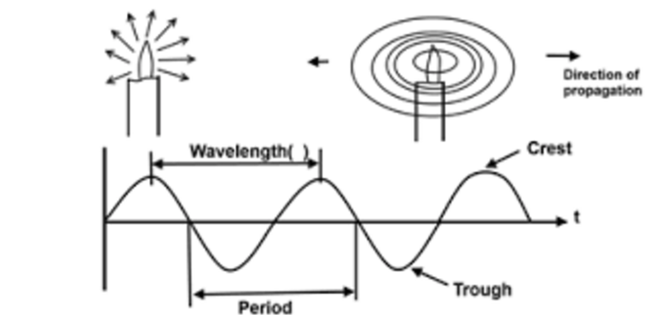

YOUNG’s DOUBLE SLIT EXPERIMENT
Thomas Young performed a famous experiment where he sone a monochromatic light (light of a single colour) on a screen containing 2 very tiny pinholes and on the other side another screen was placed where he observed the pattern produced by the light passing through the pinholes

Light should have created this:
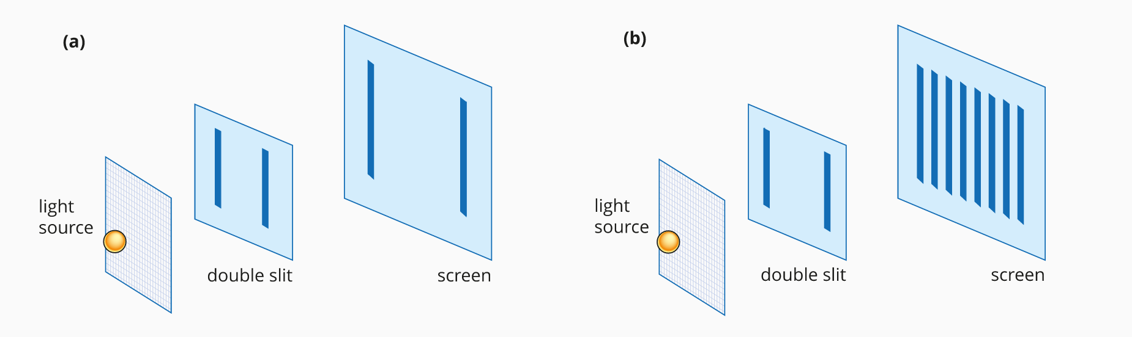

But instead, it showed this:


- Young was able to explain this pattern by treating light as a wave. He assumed that the monochromatic light was like plane waves and that, as they passed through the narrow slits, these plane waves were diffracted into circular waves.
- The interference pattern produced by these two waves would result in lines of constructive (antinodal) and destructive (nodal) interference that would match the bright and dark fringes respectively.
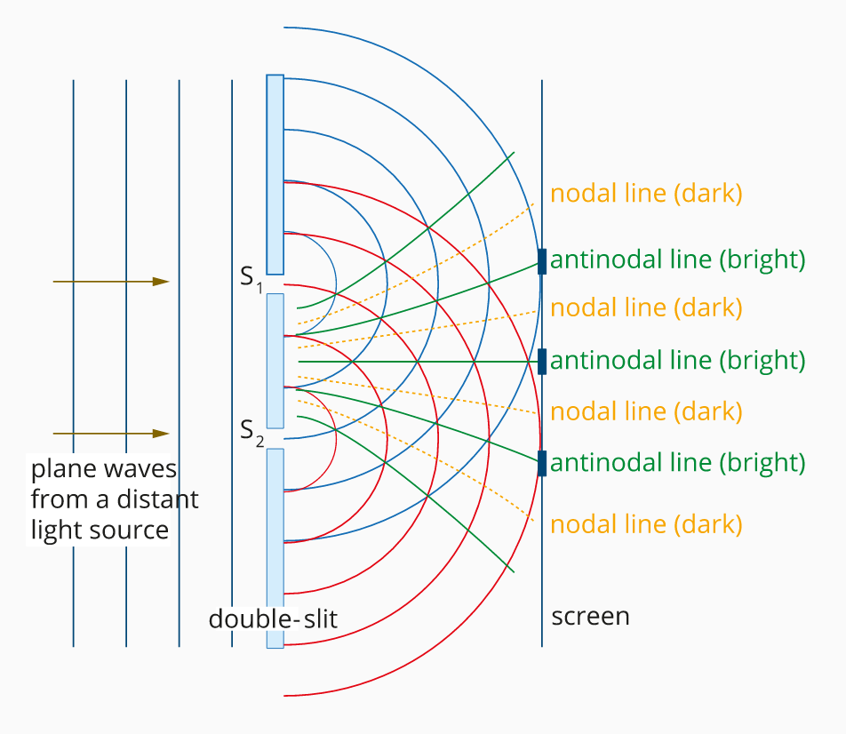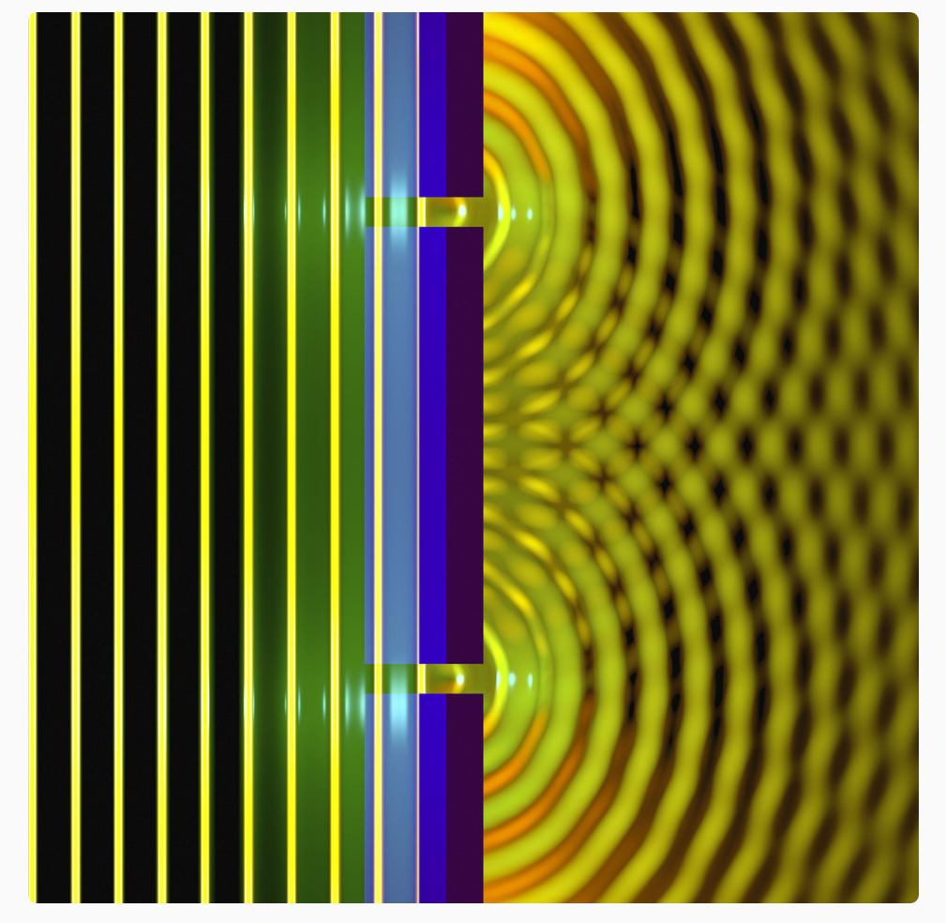

REFLECTION
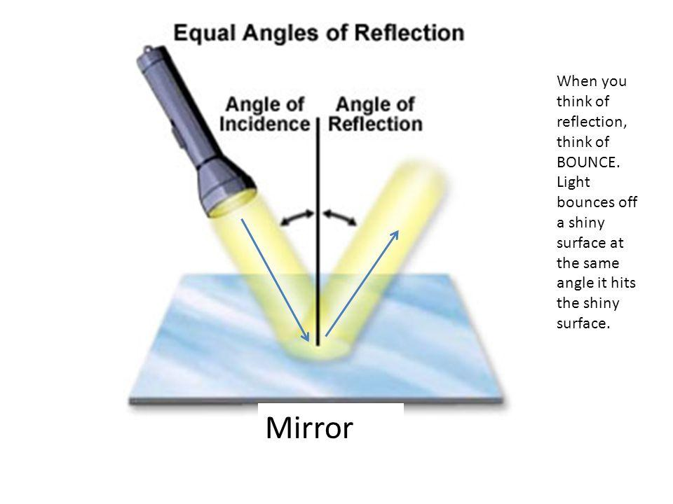

REFRACTION
- Bending of light
- caused by a change in the speed of a wave.
- light travels more slowly in glass than in air, this means that the light waves have a shorter wavelength in glass than in air. This change in wavelength causes the refraction shown.
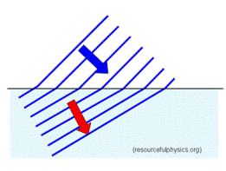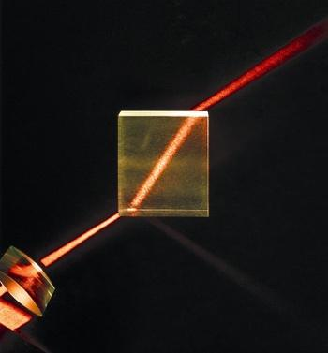

The amount of refraction depends on how much the speed of light changes as it moves from one medium to another—when light slows down greatly, it will undergo significant refraction.
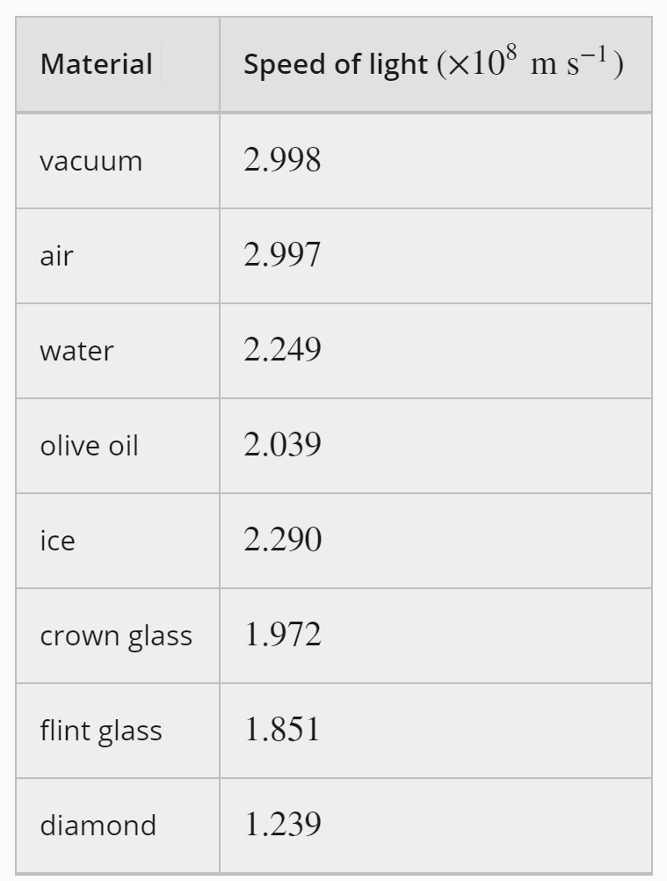

DISPERSION
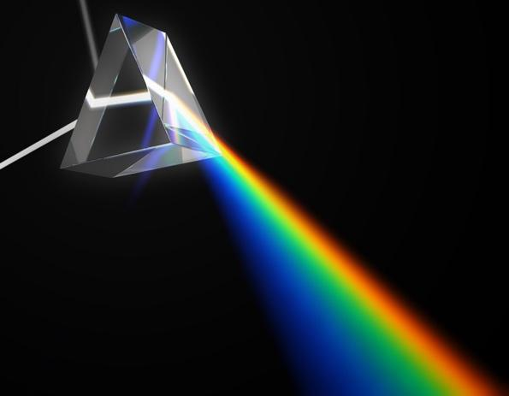
The process of light splitting into its component colours to create a spectrum or rainbow.
- When white light passes through a triangular glass prism it undergoes dispersion.
- This is a result of refraction.
- According to the wave model of light, each different colour represents a wave of a different wavelength. White light is a mixture of light waves with many different wavelengths.

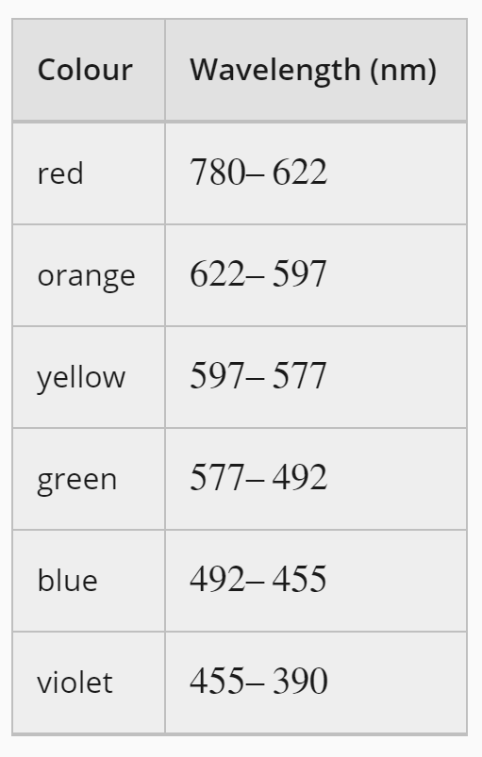

- When white light passes from one material to another and the light waves slow down, the wavelengths of each colour change by different amounts.
- Means each colour travels at a slightly different speed in the new medium and therefore each colour is refracted by a slightly different amount.
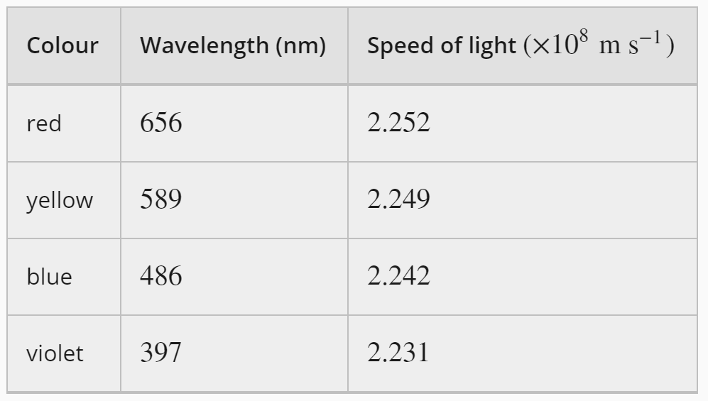
- Longer wavelengths (red) travel the fastest so are refracted the least.
- Shorter wavelengths (blue) are slower so are refracted the most.

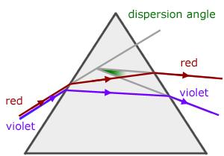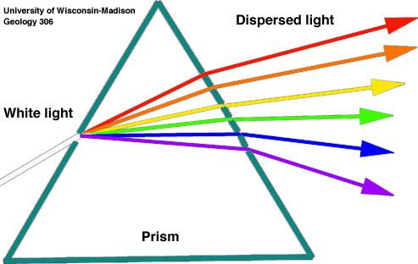

DIFFRACTION
- Significant diffraction will only occur if the light encounters barriers that are similar in size to their wavelength.
Diffraction Grating:
VIDEO

DIFFRACTION GRATINGS AND INTERFERENCE FRINGES
- Diffraction Gratings and Interference Fringes
- A system, which comprises a vast number of narrow equally spaced parallel slits, is called a diffraction grating.
- When light passes through a diffraction grating, the resultant image consists of interference fringes. In the case of white light, it undergoes dispersion

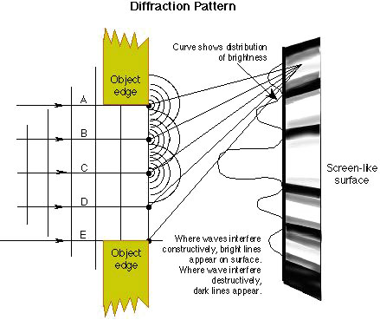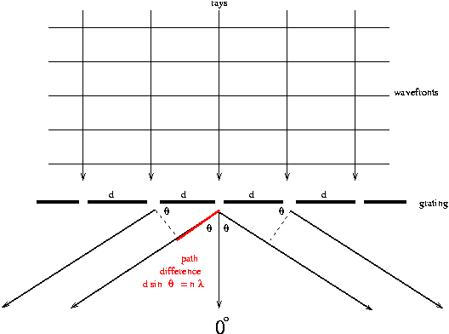
Blue light has a shorter wavelength therefore a smaller path difference is required for constructive interference to occur. This means that blue light will constructively interfere closer to the zero order fringe compared to red light which will travel further before constructively interfering.

POLARISATION
- Occurs when a transverse wave is only allowed to vibrate in one direction.
- Light produced by sources such as a globe or the Sun is unpolarised.
- Certain materials can act as polarising filters for light. These only transmit the waves or components of waves that are polarised in a particular direction and absorb the rest.
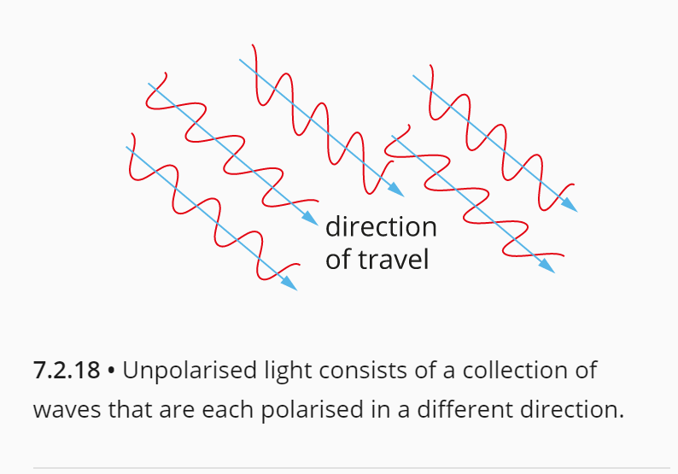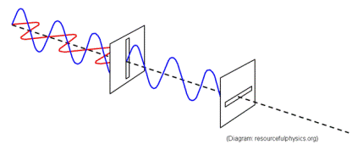

INCOMING RAY ON AN ANGLE
QUESTION

OVERLAPPING POLARISING FILTERS
VIDEO

THE PHOTOELECTRIC EFFECT
The photoelectric effect was first observed by Heinrich Hertz in 1887.
He observed that when light is shone on a highly polished metal surface, electrons can be emitted from the surface.
Investigations into the photoelectric effect showed that:
- no electrons were emitted unless the frequency of the light was above some minimum or critical (or cut-off) frequency, regardless of the intensity of the light.
- the number of electrons (the current) was proportional to the intensity. It did not vary with the frequency of the light, as long as the frequency was higher than the critical (cut-off) frequency.

WHAT IS THE PHOTOELECTRIC EFFECT?
- The emission of electrons when light is shone onto a metal surface.
- The electrons are known as 'photoelectrons' because they were released due to light or other forms of electromagnetic radiation.

THE PHOTOELECTRIC EFFECT AND THE WAVE MODEL OF LIGHT
The characteristics of the photoelectric effect could not be easily explained using a wave model of light.
- According to the wave model, the frequency of light should be irrelevant to whether or not photoelectrons are ejected.
- Since a wave is a form of continuous energy transfer, we would expect that even low frequency light should transfer enough energy to emit photoelectrons if left to shine on the metal for long enough.
- Similarly, the wave model predicted that there should be a time delay between the light striking the metal and photoelectrons being emitted as the energy from the wave built up in the metal.

LIGHT AS A PHOTON
In 1905, Albert Einstein proposed a solution to this problem. Einstein drew on Planck's earlier work on black-body radiation by assuming that light exists as particles, or 'photons' each with an energy of E=hf. This assumption made the properties of the photoelectric effect relatively easy to explain.

Equation for the energy of a photon
$E=hf$
E = energy (J)
H = Planck’s constant ($6.63×{10}^{-34}$ J.s)
f = frequency (Hz or s⁻¹)

KEY CONCEPTS OF THE PHOTOELECTRIC EFFECT
- A photocurrent is only produced when the frequency of the light is above some minimum value, called the cut-off frequency, f₀. This implies a cut-off wavelength, $λ_{o}=\frac{c}{f_{o}}$ , above which no photocurrent is produced.
- The size of the current (the number of photoelectrons produced) depends on the intensity (brightness) of the light but not the frequency, as long as the frequency is above f₀.
- There is no time delay between light being incident on the metal and photoelectrons being emitted, regardless of intensity.
- Different metals have characteristic cut-off frequencies

WORK FUNCTION
- Einstein identified that, for a particular metal, the amount of energy required to produce a photoelectron is a constant value that depends on the strength of the bonding within the metal. This energy was called the work function, W, of the metal.
- For example, the work function of lead is 4.25 eV, which means that 4.25 eV of energy are needed to release one electron from the surface of a piece of lead.
- This explains why each metal has a threshold frequency—this is the frequency at which the photons have an energy equal to the work function of the metal, i.e. W=hf₀.

GRAPHING KE OF PHOTOELECTRONS AGAINST FREQUENCY OF LIGHT HITTING THE METAL
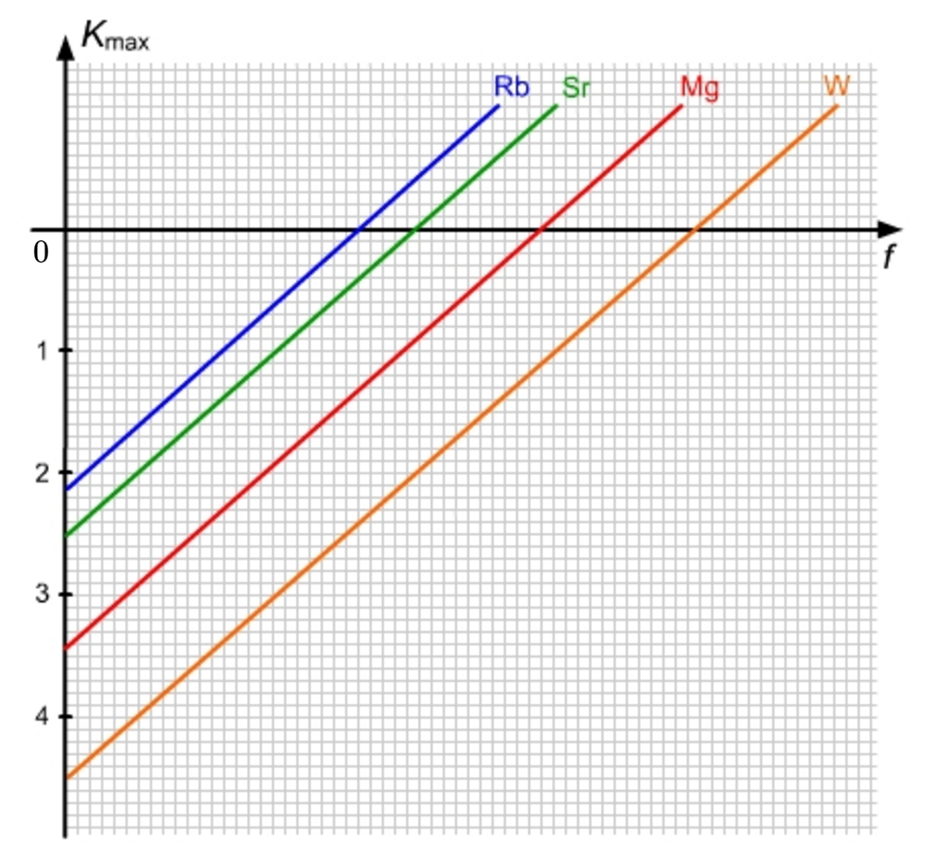

GRAPHING KE AGAINST WAVELENGTH
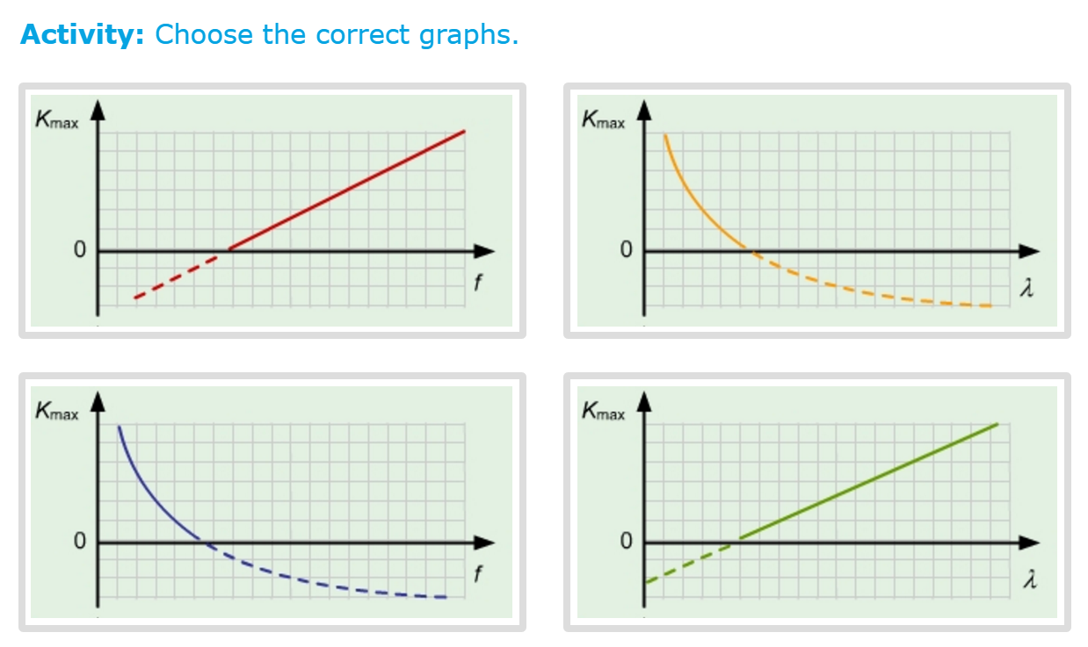
Intercept value = cut-off frequency
Bottom limit = work function

$E=hf$
$v=λf$
Combining these equations:
$E=\frac{hv}{λ} or \frac{hc}{λ}$
As v = c for light

PHOTOELECTRIC EQUATION
- If the energy of the photon is greater than the work function of the metal, then a photoelectron is released. Any excess energy in the photon is transformed into the kinetic energy of the photoelectron.

$E_{K}=hf-W$

STOPPING VOLTAGE
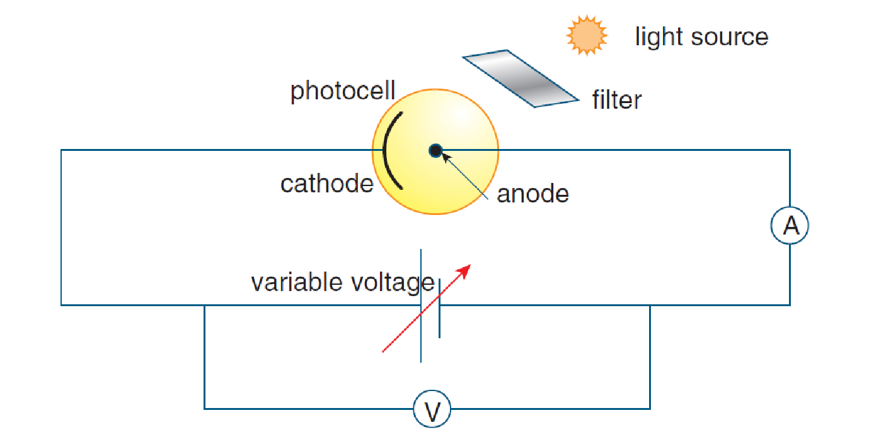
German physicist Philipp Lenard further investigated the energy of emitted photoelectrons by applying an increasing negative potential difference. As the reverse potential was increased from zero, the photoelectric current was seen to drop.
This indicated that fewer and fewer photoelectrons had the energy to overcome the negative electric potential and reach the anode. At a certain fixed value, called the stopping voltage, V₀, no photoelectric current is registered.

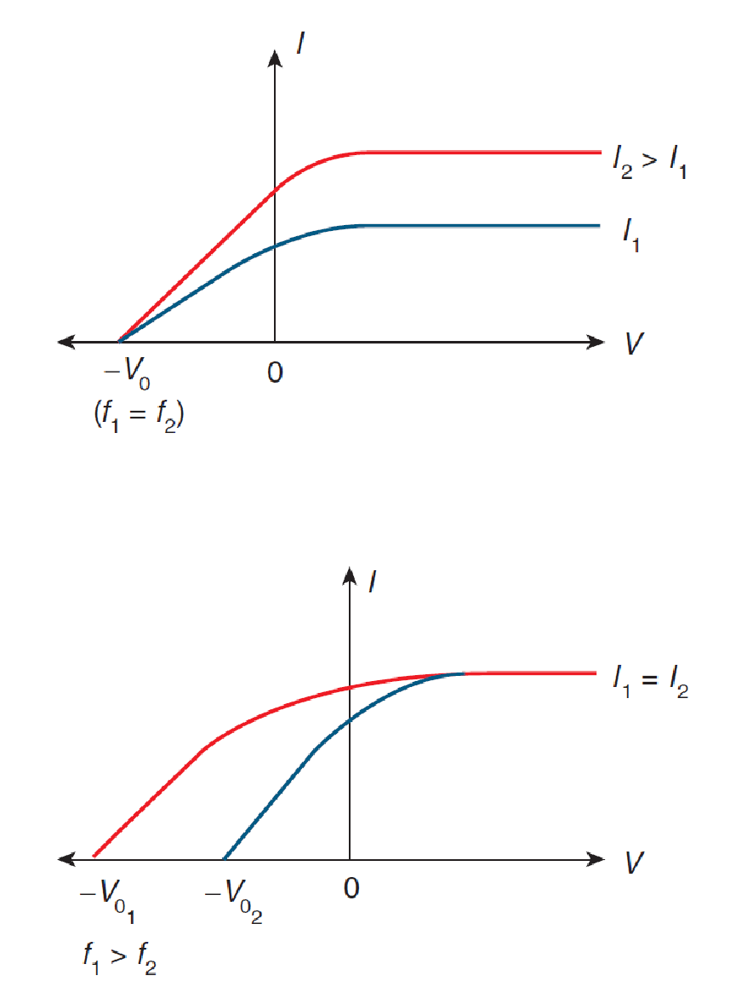
- When the applied voltage is positive, photoelectrons are attracted to the collector electrode. The current reaches its maximum value.
- When the applied voltage is negative, photoelectrons are repelled by electrode and current is reduced. −V₀ is the current for which no photoelectrons reach the collector (stopping voltage). Stopping voltage is constant for a particular frequency of light on a particular metal (totally independent of intensity).
- Light of the same intensity but different frequencies will produce the same maximum current, but the higher frequency light has a higher stopping voltage.

MAXIMUM KE OF PHOTOELECTRONS
- The photoelectrons have a range of speeds up to a maximum speed.
- As the frequency of the incident light is increased, the maximum kinetic energy of the photoelectrons increases, as seen by an increase in the stopping voltage.
- KE = eV₀ (comes from: $W=qV$)

PHOTOVOLTAIC CELLS
- The photovoltaic cells that are used in many solar panels work on the principle of the photoelectric effect. Sunlight falling on the solar panel provides energy that causes photoelectrons to be emitted as a current that can be used to drive electrical appliances.
- However, whereas many photoelectric effect experiments use high-energy photons of ultraviolet light, photovoltaic cells use materials that will produce photoelectrons when exposed to visible light. Most commonly, these are semi-conducting materials based on silicon 'doped' with small amounts of other elements.
- Although solar cells are designed to produce the highest current possible from sunlight, most commercially available solar cells have an energy efficiency of less than 20%.

ELECTROMAGNETIC RADIATION
ELECTROMAGNETIC SPECTRUM
VIDEO

ELECTROMAGNETIC RADIATION
- Transverse wave
- Created by accelerating charges which result in a rapidly changing magnetic and electric fields travelling out from the source at the speed of light.

For all EMR in a vacuum: $v=c ∴f=\frac{c}{λ}$

Energy carried by EMR $∝$ f
$E=hf=\frac{hc}{λ}$

SPECTRUM
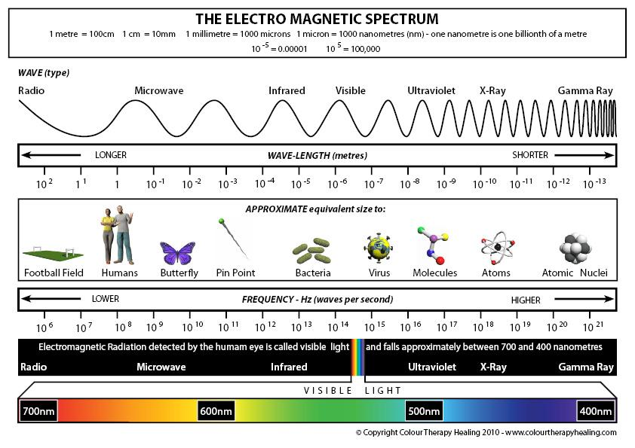
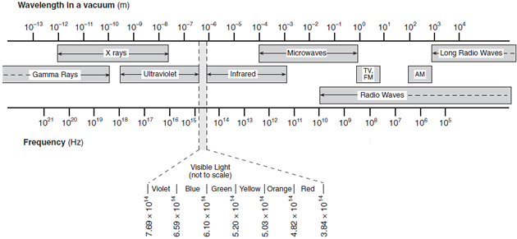

BLACK BODY RADIATION
- All objects continuously radiate energy in the form of electromagnetic waves.
- At a temperature above absolute zero a body emits radiation of all wavelengths, but the distribution or spectrum of wavelengths depends on its temperature.
- For objects at room temperature, practically all of this radiation is emitted in the infrared part of the electromagnetic spectrum, which is not visible to the human eye.
- At higher temperatures, not only is the total amount of radiation emitted larger, but also a higher proportion of it is in the visible part of the spectrum. At temperatures around 3000 K, a significant amount of energy is emitted as red wavelengths of the visible spectrum and the object appears 'red hot'.
- As the temperature of the object increases further, the proportion of the electromagnetic radiation emitted in the visible spectrum increases and more of the energy is radiated at shorter wavelengths.
- At around 6000 K energy is radiated roughly evenly across different wavelengths of the visible spectrum so the object appears 'white hot'. At 12 000 K more of the energy is being radiated in the ultraviolet and violet parts of the spectrum, so the object appears 'blue hot', like the hottest flame of a Bunsen burner.
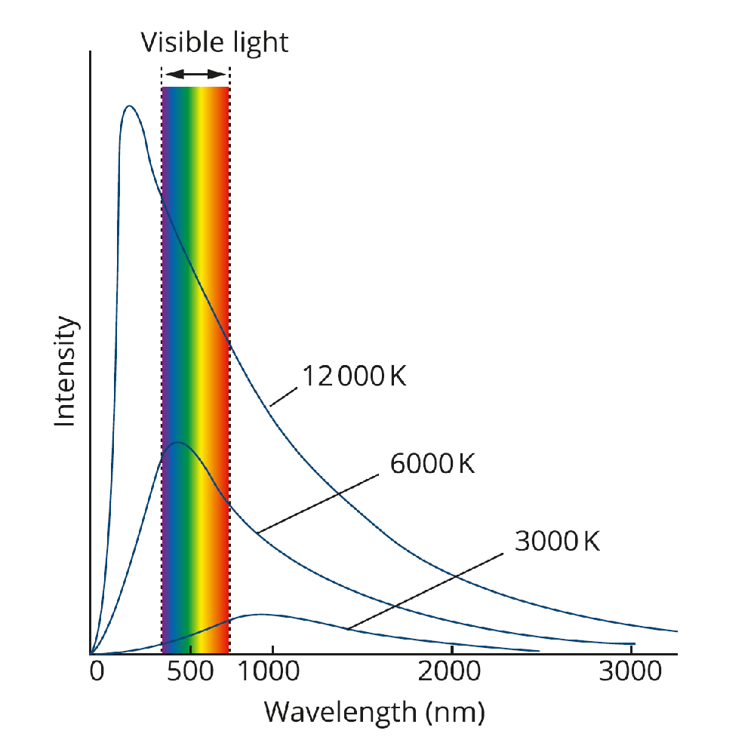
- A black body is an ideal surface that completely absorbs (and emits) all wavelengths of electromagnetic radiation incident upon it. Hence it is a black body.
- The radiation emitted is characteristic of the temperature of the black body – allows us to estimate the surface temperature of the sun by measuring its electromagnetic spectra.

BLACK BODY RADIATION AND THE WAVE MODEL OF LIGHT
- Although scientists had developed equations to explain the total amount of energy emitted by a black-body and the wavelength peak of the emission spectrum, these could not be adequately explained using the wave model of light.
- In 1900, a German Physicist named Max Planck used ‘lucky guesswork’ to derive a formula that correctly matched the experimentally observed spectrum.
- Planck proposed that the atoms could only oscillate with discrete energies, given by E=nhf.
- This was a radical proposition. It means that the energy of the oscillators is quantised. From this Planck deduced that the oscillators could only emit and absorb electromagnetic radiation (light) in packets of energy of specific sizes. He called these packets of energy ‘quanta’. 🡪 lead to the development of the photon.
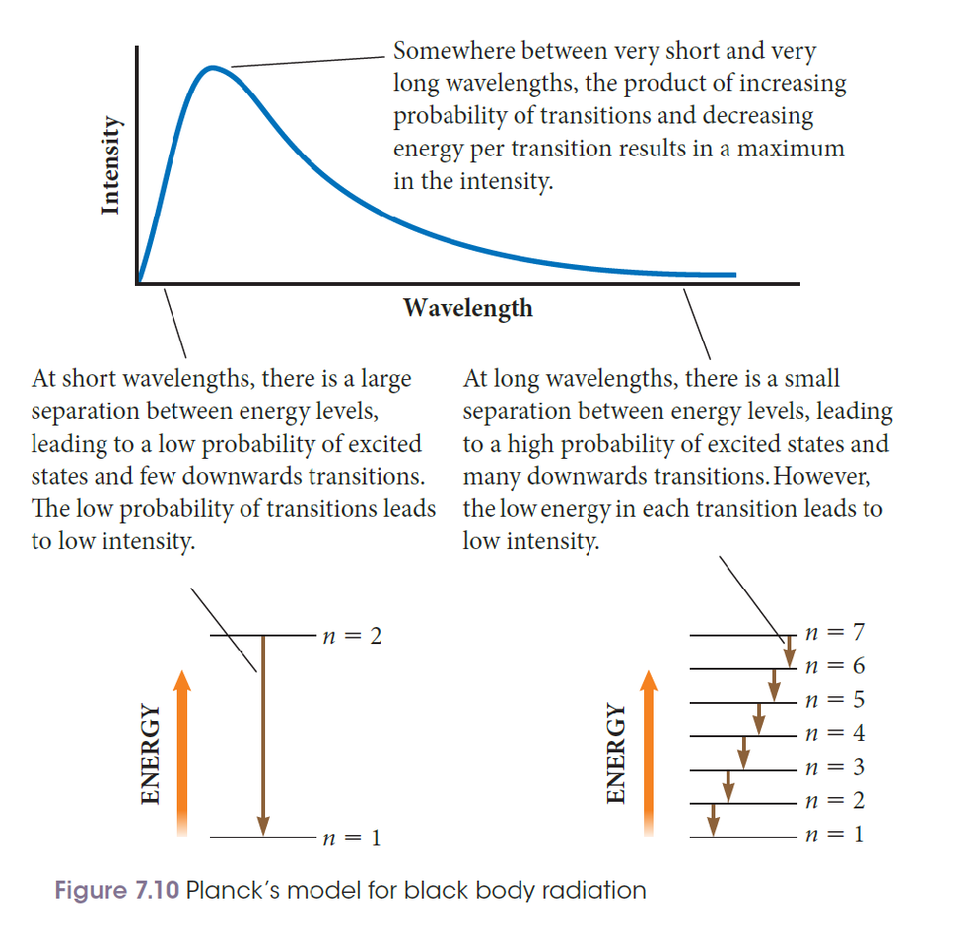

ATOMIC SPECTRA AND BOHR’s MODEL OF THE ATOM
ABSORPTION AND EMISSION SPECTRUM
- A given atom will absorb and emit the SAME frequencies of EMR
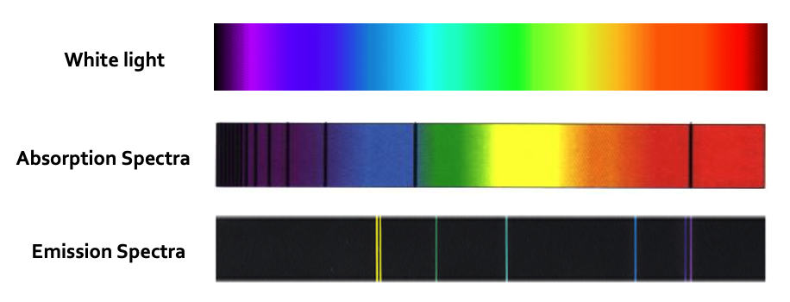
^ the 2 bottom ones are from different atoms

ABSORPTION SPECTRUM
If you observe the star through the gas, you will see a continuous spectrum with breaks where specific $λ$of energy have been absorbed by the gas cloud atoms and then re-emitted in a random direction, scattering them out of our telescope beam. = absorption spectrum
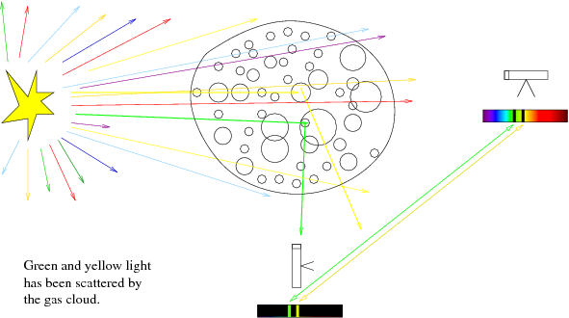

EMISSION SPECTRUM
If you observe the gas but not the star, you will only see a portion of the scattered light being re-emitted by the gas
- the continuum radiation from the star will not fall into our telescope beam, because we are pointed away from the star. = emission spectrum.

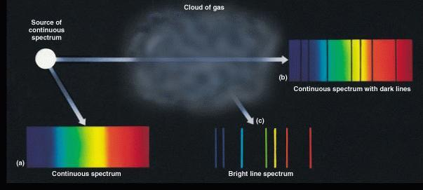

- The emission/absorption spectrum of an atom is unique to that particular atom and can provide us with clues as to the structure of atoms
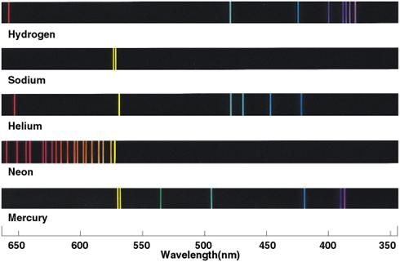

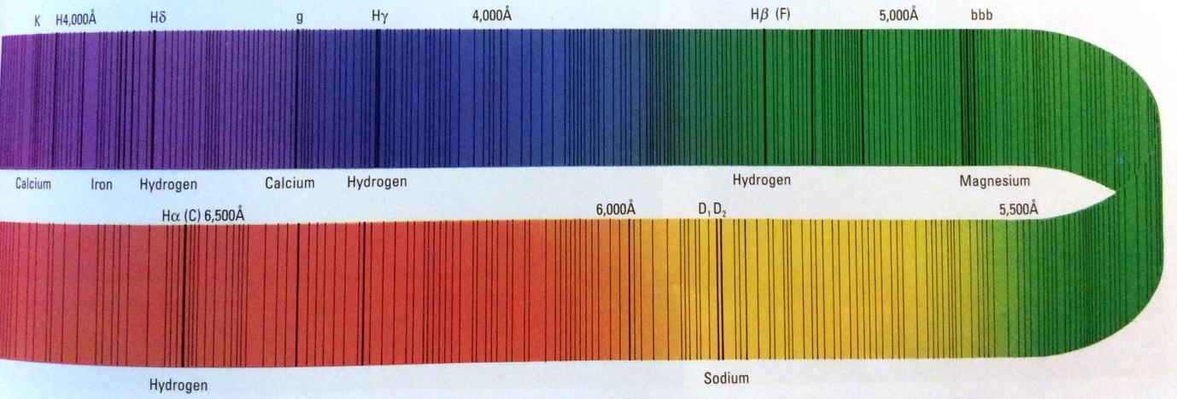
- The EMR frequencies absorbed and emitted match the allowed energy levels in the atom
- The allowed energy levels in an atom depend mostly on the electric field configuration
  - Hydrogen, with one proton in the nucleus, has a different field configuration than does Helium with two protons
  - this is why the two atoms have a different energy levels and different characteristic absorption and emission lines

THE BOHR MODEL
- The electrons move in a circular orbit around the nucleus by electrostatic forces (positive nucleus attracts negative electron)
- A number of allowable orbits of different radii exist for each atom and are labelled n = 1, 2, 3…
  - The electron may occupy only these orbits
- An electron ordinarily occupies the lowest energy orbit available
  - When in one of its allowed orbits, the electron emits no radiation
- When an electron changes from a high-energy orbit to a lower-energy orbit, the excess energy is emitted as a photon
Photon = light

If an electron in an atom moves between energy levels m and n, the energy of the photon that is either emitted or absorbed is given by:
$E_{photon}=hf=E_{m}-E_{n}$
h = Planck’s constant ($6.63×{10}^{-34}$ J.s)
f = frequency of the photon (Hz)
if eV or J are used, they must remain consistent

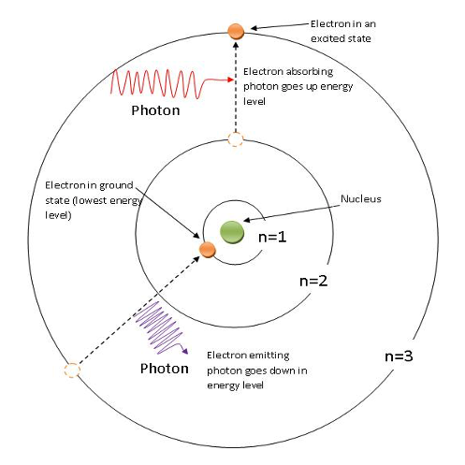

- Only photons that have just the right energy will be absorbed by the electrons
- If the photons have energy > ionization energy of the incident atom, the excess photon energy simply translates to extra K.E. of the released electron (recall the photoelectric effect)

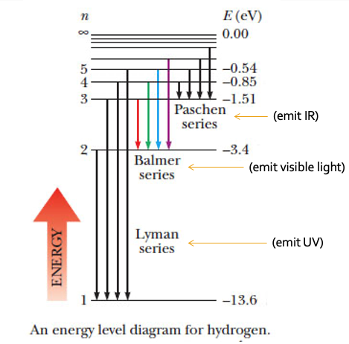
NOTE: The reason why the energies have negative values has to do with the way we define potential energy. Since a free electron must be far enough away from the nucleus that it is no longer effected by electrostatic forces (corresponding to n = $∞$ and a PE $=0$) but still maintain an overall E$≥0$ (it has KE) it makes sense that an electron bound to an atom must have E $<0$. That is, energy must be added in order to bring the electron’s total energy up, from a negative value to at least zero in order to free it.

ENERGY LEVELS FOR HYDROGEN
- Bohr used classical physics ideas to deduce that the value of the various allowed energy levels for the hydrogen atom could be represented by the equation:
$E_{n}=\frac{-13.6}{n^{2}}$
$E_{n}$ = energy of the nth level for hydrogen (eV)
n = the energy level number (1, 2, 3, …)

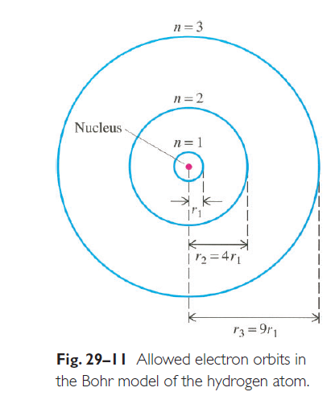
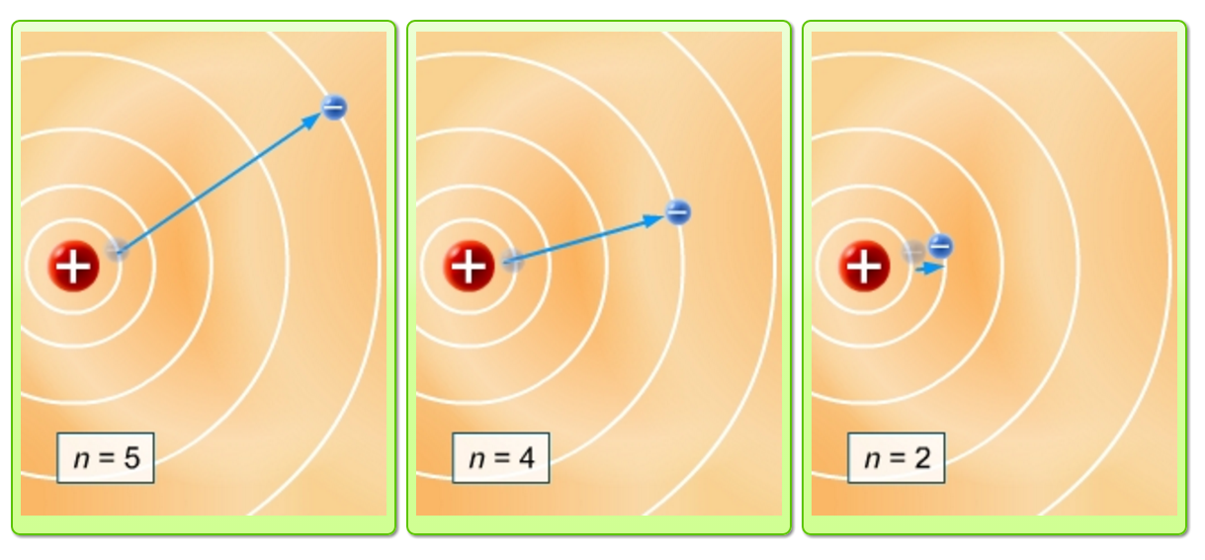
FLUORESCENCE AND PHOSPHORESCENCE
- Fluorescence occurs when a substance absorbs high energy photons such as UV and re-emits the energy as visible light
- Phosphorescence is similar to fluorescence, but the excited state is metastable, and the re-emission of energy takes place over a period of time

BAND AND CONTINUOUS SPECTRA
- Spectra can be classified into line, band (associated with molecules or polyatomic ions) or continuous (emitted from hot solids and liquids).

Band Spectra
- Differs in that board bands of frequencies are involved rather than sharp lines
- When examined closely each band of colour comprises a number of closely spaced lines
- Molecules have many more energy levels than atoms and they are in close groups They result from overlapping energy levels of the individual atoms in the molecule
- This results in more possible energy transitions, and consequently the emission spectra have a large number of lines
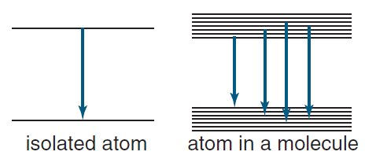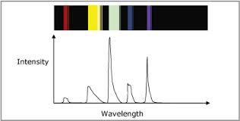

Continuous Spectra
- Continuous spectra emitted from hot solids (filament of light globe) or hot liquids (molten iron).
- In solids and liquids, atoms are so close together that their outer electrons overlap.
- The energy levels in the atoms are spread out into bands which are very close together because of the very large number of atoms.
- Consequently the full range of wavelengths is produced due to the many electron transitions that are possible.
- This type of radiation is called blackbody radiation.
- Specific characteristics depend on the temperature of the solid/liquid.
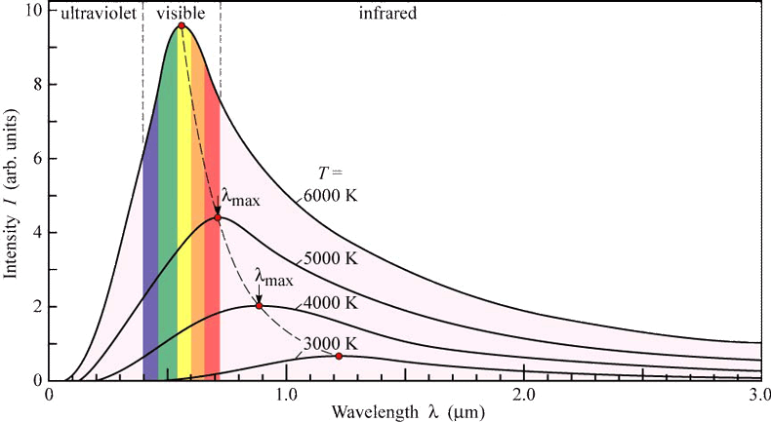

THE PROBLEMS WITH BOHR’S MODEL
- Only works for one-electron atoms (H and He⁺).
- Modeled inner-shell electrons well but couldn’t predict higher energy orbitals of multi-electron atoms.
- Couldn’t explain the discovery of the continuous spectrum emitted by solids.

DE BROGLIE WAVELENGTH
- De Broglie took Compton’s relationship for the momentum of the photon and using the classical expression for momentum came up with his expression for the wavelength of a particle.

$λ=\frac{h}{p}=\frac{h}{mv}$
m = mass of the particle
v = speed
$λ$ = de Broglie wavelength of the particle (m)
h = Planck’s constant
p = momentum of the particle (kg m s⁻¹)
*the electronvolt value of Planck’s constant does not apply when using this formula*

Applied to Bohr’s Hydrogen atom
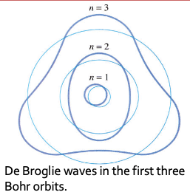
- viewed the electrons orbiting the hydrogen nucleus as matter waves.
- suggested that electrons could only maintain a steady energy level if they established a standing wave.

If a whole number of matter wavelengths ‘fit’ into the circumference of the electron orbit, then the wave reinforces itself, and a standing wave is produced, $∴$ an energy level may exist with this circumference.
Where an integral number of waves do not fit, destructive interference occurs, and the orbit cannot represent an energy level.
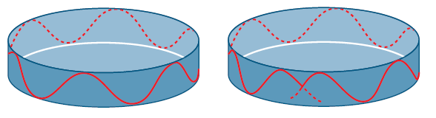

The only wavelength values that the electrons could ‘have’ were the wavelengths that fitted perfectly into the orbit
$2πr=nλ and λ=\frac{h}{mv}$
$2πr=\frac{nh}{mv}$
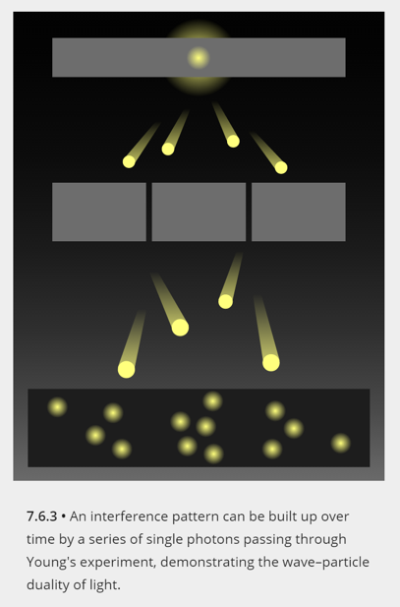
EXPERIMENTAL EVIDENCE
- In the early years of quantum theory, some scientists believed that the wave properties of light observed in Young's double slit experiment may have been due to some sort of interaction between photons as they passed through the slits together.
- Experiments were done with light sources that were so dim that scientists were confident that only one photon was passing through the apparatus at a time. These experiments produced identical interference patterns to those done with bright sources.
- Interestingly, when a detector is used to measure which slit the photon passes through, the wave pattern disappears and the photon acts like a particle.

PROOF OF DE BROGLIE’S WAVELENGTH
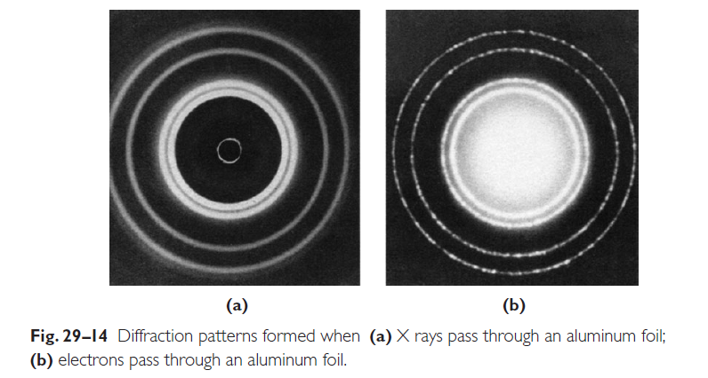
In 1927 the American physicists Clinton Davisson and Lester Germer performed an experiment that demonstrated the wave properties of electrons, thereby confirming de Broglie’s hypothesis. A beam of electrons was directed at a nickel crystal. The crystal scattered the electrons, producing a diffraction pattern similar to that produced by X rays. The diffraction pattern was used to measure the wavelength of the diffracted waves. The wavelength measured by Davisson and Germer was equal to the de Broglie wavelength predicted by the equation.

SPECIAL RELATIVITY

RELATIVE MOTION
The principle of relativity tells us:
Within a frame of reference, there is no measurement you can make that will tell you whether you are stationary or moving with a constant velocity

We can only describe an object’s motion by comparing it to another object or frame of reference.
An inertial frame of reference is one that is either moving with a constant velocity or is stationary. It is not accelerating.

Objects are always in motion relative to some other frame of reference.

THEORIES OF RELATIVITY
Einstein proposed 2 theories of relativity:
- The laws of physics are the same in all reference frames
- Light always travels through a vacuum at a fixed and constant speed. The speed of light is constant and independent of the motion of the emitting body.

NEWTONIAN PHYSICS
- The Newtonian principle that the velocities of objects and frames of reference can be added together to determine the velocity of the object in another frame of reference is common throughout his equations and laws.
- For example, if Amaya and Binh are on a train moving at 10 m/s forwards, and they roll a ball towards the front of the train at 2 m/s, then relative to the train the ball is moving at 2 m/s forwards. If Clare is standing still on a platform and sees Binh rolling the ball, then Clare will see the ball moving at 12 m/s forwards (10+2=12). If the train is moving backwards at 10 m s−110 m s−1, then Clare will see the ball move at 8 m/s backwards (−10+2=−8).

CONSTANT SPEED OF LIGHT
If we assume that Newtonian physics holds and that the speed of light isn’t constant, then the world doesn’t make sense.

THE EFFECT OF SPEED ON TIME
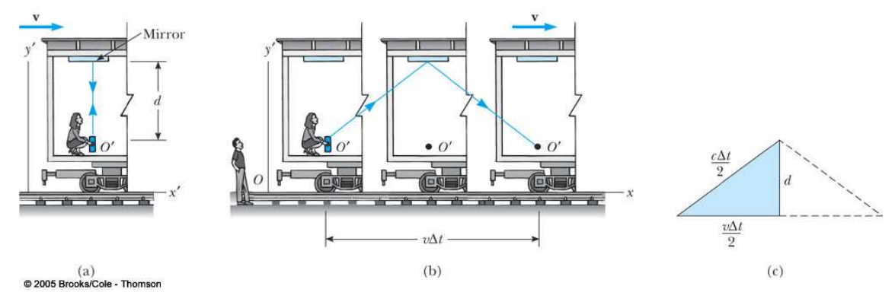
- Relative to observer O, light travels a longer distance (Figure b)
- Speed of Light = constant (2nd postulate)
- Therefore, time must slow down (time dilation)
Clocks moving relative to an observer are measured by that observer to run more slowly (as compared to clocks at rest).

MUON DECAY
Non-relativistic
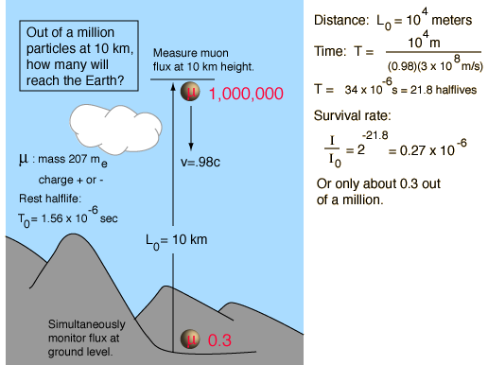

Relativistic
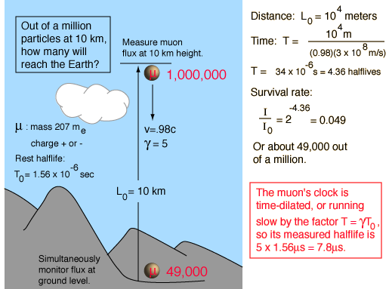

The lifetime of a muon is measured to be longer than when it is at rest.

WHY DON’T WE NORMALLY NOTICE TIME DILATION?
Time dilation effects are negligible unless v is reasonably close to c. The speeds we experience in everyday life are much smaller than c, so we don’t ordinarily notice time dilation.
In 1971, extremely precise atomic clocks were flown around the world in jet planes. The speed of the planes (10³ km.h⁻¹) was much less than c, so the clocks had to be accurate to the nanosecond in order to detect any time dilation. The clocks were accurate enough to record the effects of time dilation.

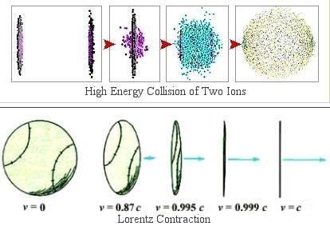
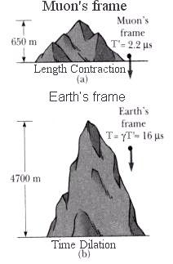
Length of an object is measured to be shorter when it is moving relative to the observer than when it is at rest.
It only occurs along the direction of motion.

Proper time, t₀ – the time as measure by the observer in the same frame of reference as the clock.


Proper length, l₀ – the length of the object (or distance between two point) as determined by the observers at rest with respect to the distance.
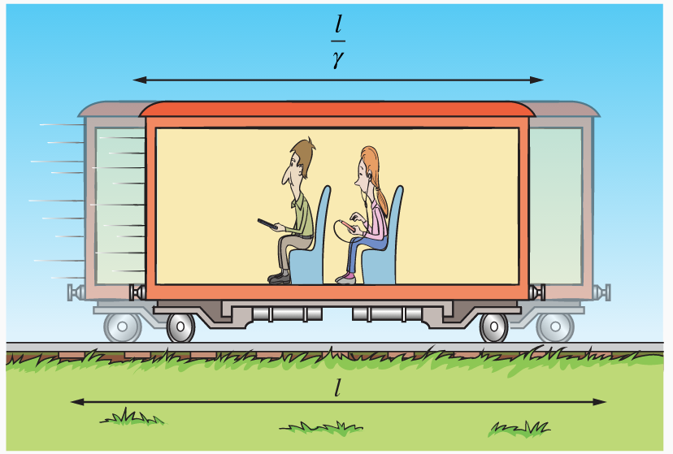

LENGTH CONTRACTION AND TIME DILATION FORMULAS: (ON BOARD)

THE LORENTZ FACTOR
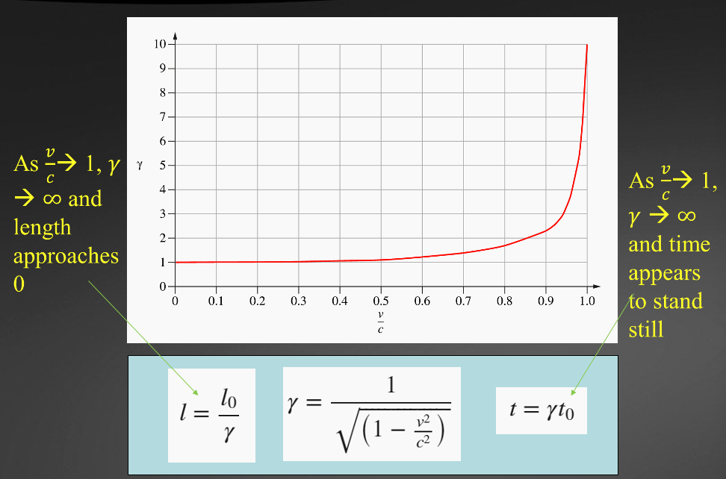

THE EFFECT OF SPEED ON MOMENTUM
The analysis of collisions between 2 particles shows that if we want to preserve the law of conservation of momentum in relativity, we must redefine relativity as:
$p=\frac{mv}{\sqrt{1-\frac{v^{2}}{c^{2}}}}=γmv$
At very low speeds this equation reduces to the classical momentum equation $p=mv$

THE EFFECT OF SPEED ON ENERGY
As the momentum of an object increases, so does its kinetic energy
$E_{k}=\frac{1}{2}mv^{2}$
$=\frac{1}{2}(mv)×v$
$=\frac{1}{2}pv$

$E_{total}=E_{0}+E_{k}$
$=mc^{2}+\left(γ-1\right)mc^{2}$
$=mc^{2}+γmc^{2}-mc^{2}$
$=γmc^{2}$

RELATIVISTIC ENERGY
$E=\frac{mc^{2}}{\sqrt{(1-\frac{v^{2}}{c^{2}})}}$

RELATIVISTIC ADDITION OF VELOCITIES
Consider a situation in which a spaceship moving at 0.90c fires a rocket forwards at a speed of 0.20c. According to classical physics, a stationary observer would see the rocket moving at 1.10c, which is a speed faster than light. This is an impossible situation.

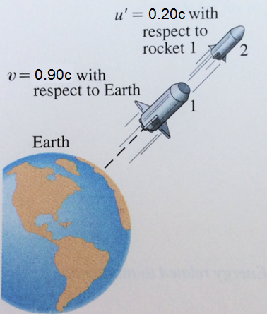

Einstein showed that since length and time are different in different reference frames, the old addition-of-velocities formula is not longer valid. Instead the correct formulae, for motion along a straight line, are:
$u=\frac{v+u'}{1+\frac{v u'}{c^{2}}}$

$u'=\frac{u-v}{1-\frac{u v}{c^{2}}}$
u’ = velocity of an object moving in frame S’
u = velocity of the same object as viewed from frame S
v = relative velocity between reference frame S and S’

THE SPECIAL THEORY OF RELATIVITY
What’s so special about the special theory of relativity?
- The theory only applies in the special case where there are no gravitational fields.
- A more comprehensive theory is required to describe the behaviour of objects in the presence of gravitational fields.

THE GENERAL THEORY OF RELATIVITY
The general theory is a theory of gravitation.
The general theory unifies special relativity and Newton’s law of universal gravitation.
- Space and time merge to form spacetime.
- Spacetime has four dimensions: length, width, height and time.
- The geometry of spacetime is distorted by massive objects.

According to the general theory:
- gravity isn’t a force.
- objects are attracted towards Earth because of the distortion of spacetime around it.

THE EFFECT OF GRAVITY ON LIGHT
- Photons have no mass, so light shouldn’t be affected by gravity.
- However, massive objects distort spacetime, causing light to bend towards them.

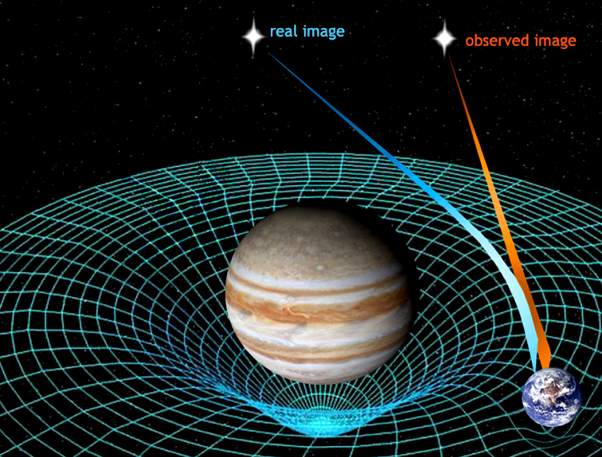

- A, B, C & D are images of the same distant quasar.
- Multiple images are produced when a massive object in the foreground distorts spacetime.
- This effect is called gravitational lensing
- When gravity becomes so strong that light can’t escape, a black hole is said to exist.

THE EFFECT OF GRAVITY ON TIME
- To an external observer, time appears to run slower in stronger gravitational fields.
- Clocks on Earth run slower than those on orbiting satellites.
- This effect is critical to the accuracy of global positioning systems (GPS).

NEWTON vs EINSTEIN
- Newton’s laws are still used to explain motion at speeds normally seen on Earth.
- At ‘normal’ speeds, relativistic changes in mass, length and time are insignificant.
- It’s only when objects approach the speed of light, that relativistic effects become significant.

GRAVITY
- In weak gravitational fields, predictions based on Newton’s law are consistent with those of general relativity.
- In strong gravitational fields, relativity explains many phenomena unknown in Newton’s lifetime.

- The special theory of relativity describes the effects of relative motion on time, mass and length; and the equivalence of energy and mass.
- The general theory of relativity describes the effects of gravity on light and spacetime.
- Both Newton’s law of universal gravitation and Einstein’s relativity theories are currently used to explain how the Universe works.

THE STANDARD MODEL

THE HISTORY OF PARTICLE ACCELERATORS
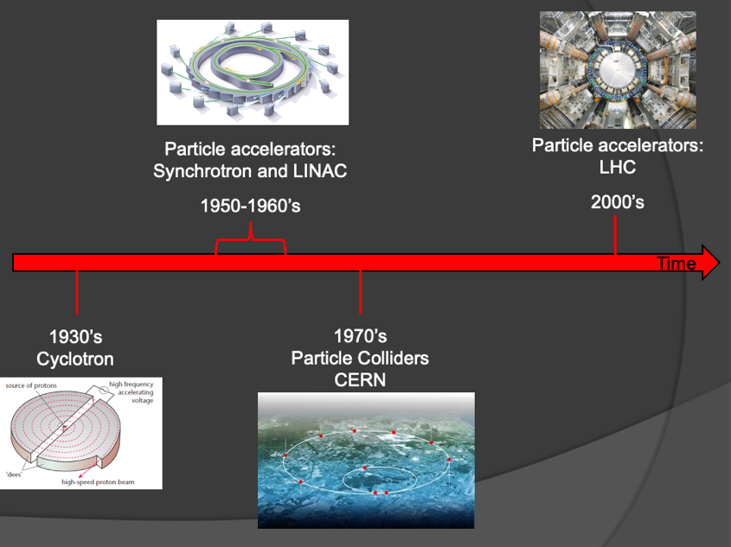

CYCLOTRON
One of the earliest types of particle accelerators and is still used as the first stage of some large multi-stage particle accelerators. It led to the development of particle physics and revolutionary discoveries about the nature of the universe.
- Makes use of the magnetic force on a moving charge to bend moving charges into a semicircular path between accelerations by an applied electric field.
- The applied electric field accelerates electrons between the "dees" of the magnetic field region.
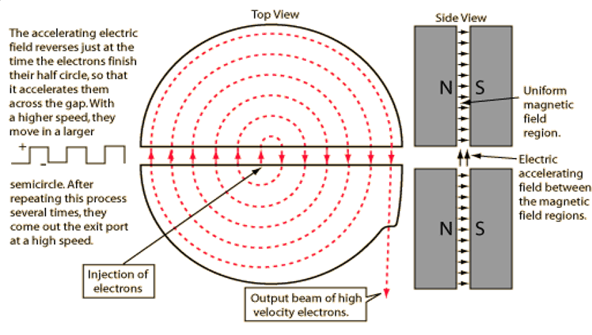

What provides the centripetal force that acts on the charged particles?
- The magnetic force

Why does the accelerating charge move in a “expanding helix” rather than a circle?
As the charge is accelerated across the gap by the reversing electric field its velocity increases resulting in an increasing radius. Thus an “expanding helix” shape
$F=ma$
$qvB=\frac{mv^{2}}{r}$
$∴v=\frac{qBr}{m}$

PARTICLE ACCELERATORS: LINEAR ACCELERATORS (LINAC)
- Electrons or ions are accelerated by an electric field (which is actually radio waves) along a straight-line path, passing through a series of drift tubes.
- Voltage applied to the tubes is alternating so that when an electron (say) reaches a gap, the tube in front of them is positive and the one they just left is negative.
- Many hospitals use linear accelerators to produce $γ$ rays to irradiate tumors.

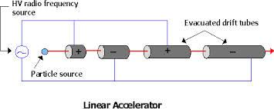
Tubes get longer as the particle is being accelerated, and as the particle must spend the same amount of time in each tube (which will correspond to the frequency of the voltage source) the tube must get longer (t=s/v).

The linear accelerator can accelerate electrons to approximately 99.9% of the speed of light. What voltage must be applied between the anode and cathode to achieve this speed?
$\frac{1}{2}mv^{2}=qV$
$∴V=\frac{mv^{2}}{2q}=2.56×{10}^{5}V$

PARTICLE ACCELERATORS: SYNCHROTRON
- Electrons travelling at speeds close to the speed of light under ultra high vacuum conditions have their paths changed by powerful electromagnets.
- Changing the path of the electrons produces synchrotron light.
- These powerful beams of light can be used to examine the atomic and molecular detail of a wide range of materials.
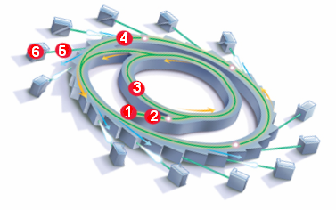
- Electron gun
- Linac
- Booster ring
- Storage ring
- Beamlines
- End station

Why is synchrotron light so useful?
- Brilliant: the high intensity allows researches to collect more detailed and accurate information in a shorter time then conventional methods.
- Wide spectrum: the light emitted covers a continuous wide range of wavelengths simultaneously.
- Tuneable: a single or range of wavelengths can be selected for specific experiments.
- Pulsed: light emitted in extremely short flashes so changes in a sample over a short period can be evaluated.
- Collimated: precisely focused so extremely small areas of a sample can be investigated.
- Polarised: improves sensitivity

PARTICLE COLLIDERS: CERN AND LHC
High energy physics can be done by allowing high energy particles to strike a stationary target. But to gain the maximum possible collision energy from a given accelerator, two beam particles are accelerated to very high energy and are steered so that they collide head on.
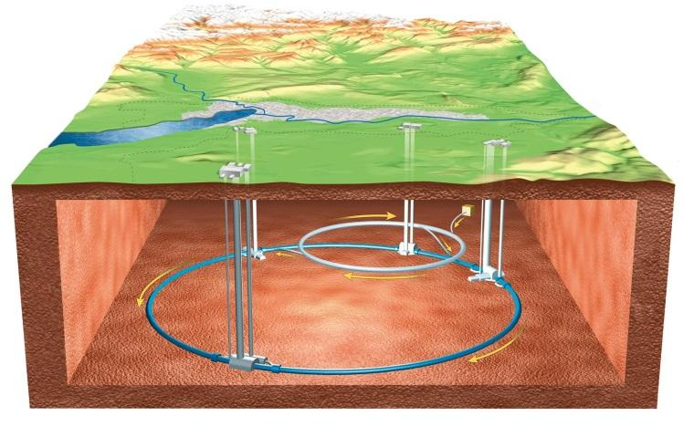

One way to accomplish such colliding beams with a single accelerator is through the use of storage rings, in which oppositely revolving beams (cause by accelerating oppositely charged particles of equal mass, e.g. proton and antiproton) can be respectively bought in to collide with one another at particular points.
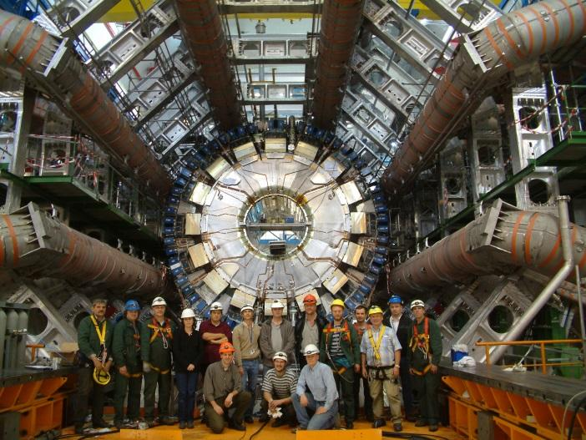

- Largest and most powerful particle accelerator.
- Consists of a 27-kilometre ring of superconducting magnets with a number of accelerating structures to boost the energy of the particles along the way.
- Inside the accelerator, two high-energy particle beams travel at close to the speed of light before they are made to collide. The beams travel in opposite directions in separate beam pipes – two tubes kept at ultrahigh vacuum. They are guided around the accelerator ring by a strong magnetic field maintained by superconducting electromagnets.
- Just prior to collision, another type of magnet is used to "squeeze" the particles closer together to increase the chances of collisions. The particles are so tiny that the task of making them collide is akin to firing two needles 10 kilometres apart with such precision that they meet halfway.

WHY BUILD PARTICLE COLLIDERS? AND HOW DOES IT ALL WORK?
- Purpose is simple but ambitious: to crack the code of the physical world; to figure out what the universe is made of; in other words, to get to the very bottom of things.
- When two particles with an equal magnitude of momentum collide head on, the total momentum is zero before and after the collision.
- If particles are stationary after the collision then their kinetic energy is zero. By the conservation of energy and mass principle, the energy before the collision is transformed into the mass of new particles formed in the collision.
- The particles that are present after a collision reaction can be different to those that went in. This is exactly what particle physicists aim to achieve and the discovery and study of these new particles underpins their work.

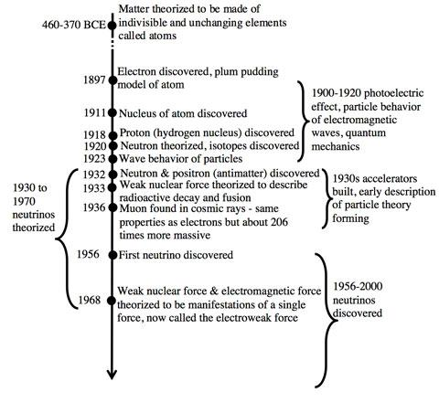

EVIDENCE FOR THE BIG BANG
Big Bang theory is supported by a number of key scientific discoveries, including:
- the expansion of the Universe,
- the abundance of hydrogen and helium in the Universe, and
- cosmic microwave background radiation.

DISCOVERY 1 – THE EXPANSION OF THE UNIVERSE
In 1912, Vesto Slipher observed that spectral lines in light from galaxies were shifted from their normal positions.
He explained these shifts by suggesting that galaxies were moving towards or away from us.

The Doppler Effect
- Spectral shifts can be explained using the Doppler effect.
- Light from an object moving away from us appears to have a longer wavelength (it is shifted toward the red end of the spectrum).
- Light from an object moving towards us appears to have a shorter wavelength (it is shifted towards the blue end of the spectrum).
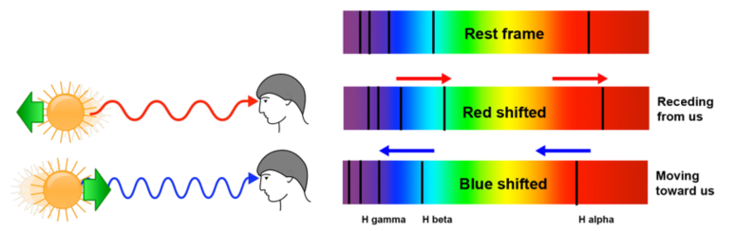

Velocities of galaxies
- Slipher used measurements of spectral shifts to calculate velocities of galaxies.
- He discovered that a few galaxies were approaching Earth, but most were moving away.
- This information was later interpreted as evidence for the expansion of the Universe.
- We now know that some objects within our local group of galaxies are blueshifted (approaching us), but most are redshifted (moving away). This is due to the Doppler effect.

Cosmological redshift
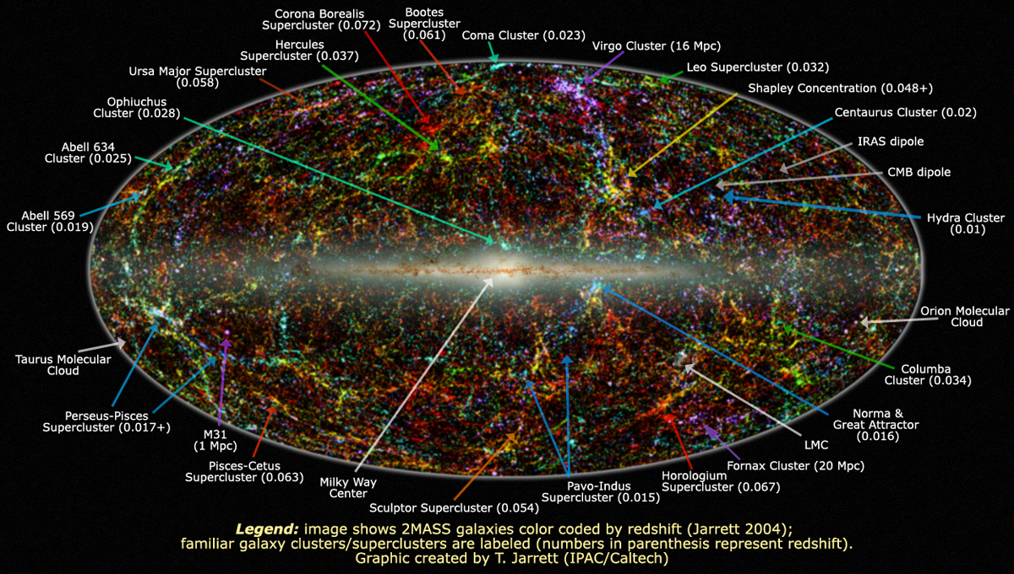

The spectra of galaxies
- Hubble observed and recorded spectra of faint galaxies
- He compared them with spectra of laboratory standards and calculated their velocities
$v=\frac{Δλ}{λ}×c$
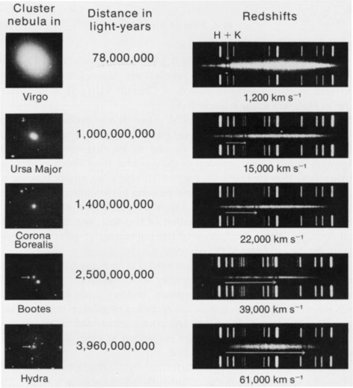

HUBBLE’S LAW
He plotted their distance against velocity and developed Hubble’s Law, which states:
The rate at which astronomical objects move apart from each other is proportional to their distance from each other.
$v = HσD$
$Hσ$ = the Hubble constant
D = the distance to a galaxy
v = its velocity

Hubble’s plot of galaxy distance vs velocity
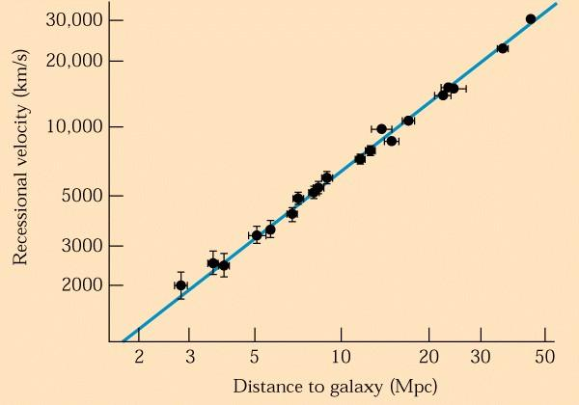

Conclusions from Hubble’s Law
Either:
Earth is at the centre of the Universe, or
the Universe is expanding.
- Which explanation is most likely?
The Hubble ultra deep field image shows galaxies from an ancient era when the Universe was younger, denser and warmer.

Hubble’s Law – Summary
- All moving objects have a Doppler effect in their spectrum showing the relative speed to the observer.
- Redshift indicates the object is moving away.
- Hubble’s Law states that the more distant the object, the faster it is moving, hence a faster moving object will have a greater redshift.
- Hubble’s Law also indicates that there is a common origin to the universe.

DISCOVERY 2 – THE ABUNDANCE OF HYDROGEN AND HELIUM IN THE UNIVERSE
Nucleosynthesis
- Big Bang theory explains that protons and neutrons fused together to form deuterium and helium in the first few minutes of the Universe.
- The process where protons and neutrons combine to produce atomic nuclei is called nucleosynthesis.

Neutrons
As the Universe cooled, neutrons:
- decayed into protons and electrons, or
- combined with protons to form deuterium.
Soon after, deuterium nuclei combined to form helium and small amounts of lithium.
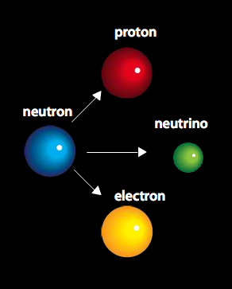

- The predicted abundance of hydrogen and helium depends on the density of the early Universe.
- Observations indicate that about 24% of the Universe is helium, produced shortly after the Big Bang.
- The predicted amounts of deuterium, helium and lithium agree closely with observed amounts.
- This is a major success for the Big Bang Theory.
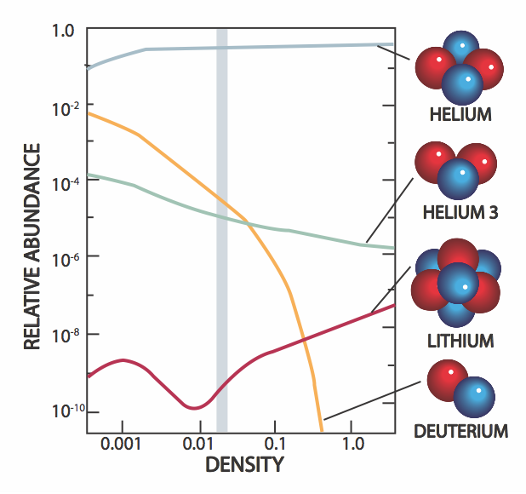

Summary
- The Big Bang theory predicts that the early universe was made up of one He nucleus for every 12 H nuclei. From this it was predicted that He made up about 24% of the mass of the early universe.
- This agrees closely with observations, therefore supporting Big Bang theory.

DISCOVERY 3 – COSMIC MICROWAVE BACKGROUND RADIATION
- The Universe became transparent to radiation about 370 000 years after the Big Bang.
- Photons from this time still fill the Universe, but their wavelength has stretched (to microwave EMR) as the Universe has expanded.
- In 1965, radioastronomers Penzias and Wilson discovered a 1.9 mm microwave background radiation that evenly fills the observable Universe.
- Properties of this radiation match predictions from Big Bang theory.

The Cosmological Principle
- Cosmic microwave background radiation is a good illustration of the cosmological principle.
- It tells us that matter in the Universe is homogeneous (uniform density) and isotropic (the same in all directions).
- It means that the Universe has no centre or edges - it is the same throughout.

Wilkinson microwave anisotropy probe
- However, small variations in the cosmic microwave background radiation have been discovered.
- They were measured by the Wilkinson microwave anisotropy probe (WMAP) spacecraft, which was launched in June 2001.
- Cosmologists propose that minute variations in CMBR are evidence in variations in the density of matter in the early universe that led to formation of galaxies.

WMAP results
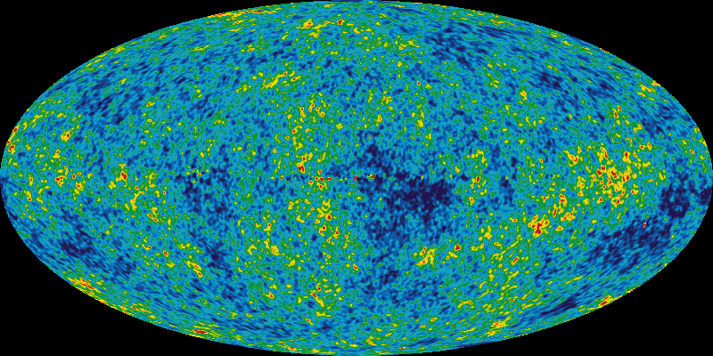
Red = warmer, blue = cooler

CMBR Summary
- CMBR tells us that matter in the Universe has uniform density (only minute – parts per million - variations occur) and is the same in all directions.
- CMBR are the remnant photons from the early universe - red-shifted to microwave spectra

ALTERNATIVES TO BIG BANG THEORY
- The Big Bang theory is considered to be our most successful theory of cosmology because it explains most experimental observations.
- Refinements to the theory are continually being made as observations are improved.
- Mathematical theories, including string theory and supersymmetry, may one day offer a deeper understanding of the origin of the Universe, but today’s evidence for the Big Bang is very strong.

STORY OF QUARKS
- What we tell students is that the fundamental particles in nature are the proton, neutron and electron.
- The actual situation is far more quirky, strange and charming than this.
- As a spin-off from the investigations into the nucleus that were conducted during the latter stages of the Second World War, particle physicists began to recognize that as the energy of the bombarding particle was increased new particles were being formed.

WHY IS IT LIKELY THAT ‘NEW’ PARTICLES WILL BE DISCOVERED IN THE LARGE HADRON COLLIDER?
Collisions in the LHC release energy, which is converted into mass according to Einstein’s equation, E = mc². This results in the formation of particles, some of which decay into other particles. Heavier particles can be produced only when large amounts of energy are involved.

- an atom is mostly open space,
- an atomic nucleus is very small and positively charged, and
- electrons orbit the nucleus like planets around a star.

RUTHERFORD EXPERIMENT AND MODEL
In 1911, Rutherford fired alpha-particles at a sheet of gold foil.
He expected the alpha-particles to be deflected slightly.
A few particles deflected through angles greater than 90°.
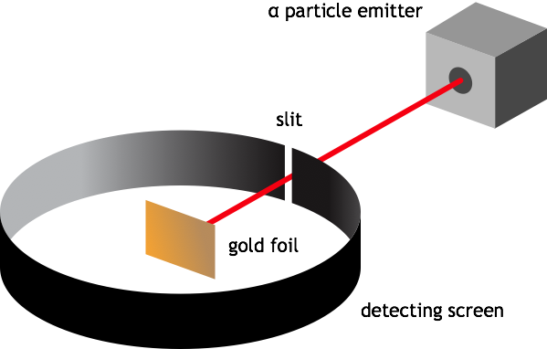

The model couldn't explain the observed line emission spectra of elements, such as hydrogen
Rutherford explained his results via a model for the atom that had a very small positively charged nucleus with negatively charged electrons orbiting like planets around a star.

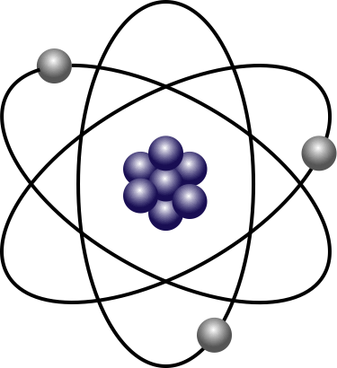

BOHR-RUTHERFORD ATOM
The neutron is missing (it was not discovered until 1932). The model isn’t able to explain atomic mass or the existence of isotopes.

Bohr believed that electrons only exist in discrete (quantised) energy levels in which they don’t radiate energy as they orbit the nucleus.
Electrons only radiate energy when they move to lower energy levels.
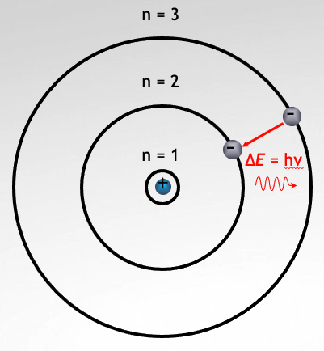

A NEUTRON
At that time, the model successfully explained many observations about the atom, including atomic mass and the existence of isotopes.
In 1932, Chadwick discovered the neutron.
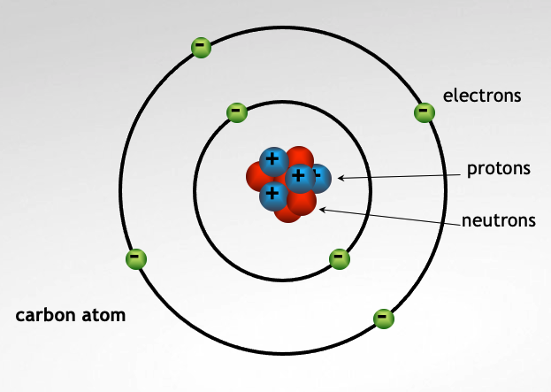

AFTER THE WAR
After the war physicists were building particle detectors and then waiting for high energy cosmic rays from space to smash into their targets, in order to see what nuclear fragments they could identify.
During the 1930s and 1940s, physicists studied interactions between matter and radiation, including cosmic rays. Many ‘new’ sub-atomic particles were discovered.

It was recognized that in order to probe more effectively into the nucleus physicists needed to build more powerful machines to accelerate protons and electrons to energies high enough to form the particles that they were predicting would exist and to expose the fundamental forces in nature.
Particle accelerators were developed in the 1960s, enabling higher energy interactions to be studied.
This soon led to the discovery of more than 100 sub-atomic particles, including the antiproton and neutrino.

QUARKS
In 1969, the quark model was proposed to make sense of the increasing numbers of sub-atomic particles.
The first generation quarks were called up and down.
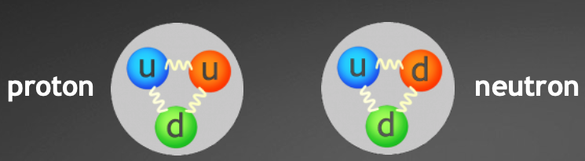
Protons and neutrons are made of up and down quarks.

The model was gradually expanded to six quarks:
quark | up | charm | top
charge | +⅔ e | +⅔ e | +⅔ e
mass | 2.5 MeV/c² | 1270 MeV/c² | 171 000 MeV/c²
quark | down | strange | bottom
charge | –⅓ e | –⅓ e | –⅓ e
mass | 5 MeV/c² | 105 MeV/c² | 4200 MeV/c²

HADRONS
Like social elephants, quarks only exist in groups with other quarks and are never found alone (quarks are held together by the strong force which is mediated by gluons). The particles that are made of quarks are called Hadrons
Although individual quarks have fractional electrical charges, they combine such that hadrons have a net integer electric charge. Another property of hadrons is that they have no net colour charge even though the quarks themselves carry color charge

BARYONS AND MESONS
There are two classes of hadrons:
Baryons:

Any hadron which is made of 3 quarks (qqq)

Because they are made of 2 up quarks and 1 down (uud) so protons are baryons. So are neutrons (udd)

Mesons:

Contain 1 quark (q) and 1 antiquark (q)

One example of a meson is a pion ($π$⁺), which is made up of an up quark and a down antiquark. The antiparticle of a meson just has its quark and antiquark switched, so an antipion ($π$⁻) is made of a down quark and an up antiquark

Because a meson consists of a particle and an antiparticle, it is very unstable. The K meson lives much longer than most mesons, which is why it was called “strange” and gave this name to the strange quark, one of its components

THE STANDARD MODEL
We now believe that all matter is made up from six quarks and six leptons, held together by forces carried by bosons.
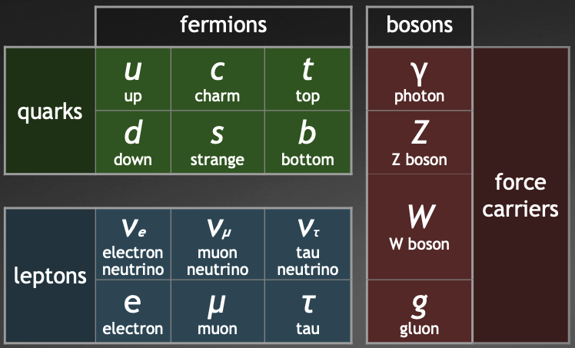
For most particles, there is a corresponding antiparticle with the same mass but opposite electrical charge. For example, the electron’s antiparticle is the positron.

Quarks
‘up’ and ‘down’ are the lightest and most common quarks. They make up all protons and neutrons
‘charm’, ‘strange’, ‘top’ and ‘bottom’ are heavy quarks. They rapidly decay to form ‘up’ and ‘down’ quarks. They are only produced in high energy collisions.

Leptons
Leptons include electrons and neutrinos. Neutrinos often travel close to the speed of light, have no electric charge, and can travel through matter almost undisturbed. They have a small mass.
They also do not experience the strong force and therefore can exist by themselves.

Force Carriers
Bosons are force carriers
Photons carry the electromagnetic force. W and Z bosons carry the weak force that is responsible for radioactive decay. Gluons carry the strong force that binds quarks together

A QUESTION OF MASS
The total mass of the quarks in a proton only accounts for 9% of its mass.
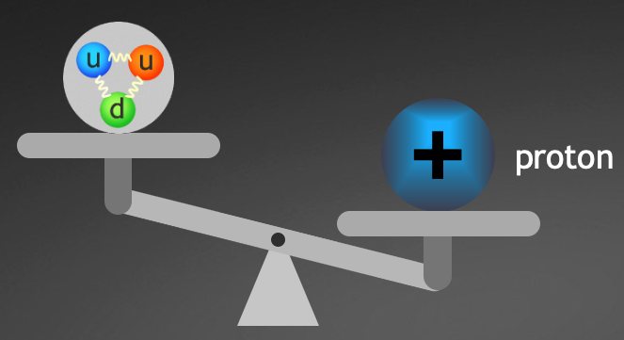

THE HIGGS BOSON
- Discovered in 2012
- is responsible for giving other particles their mass;
- and has a large mass, so it can only be produced when huge amounts of energy are released.

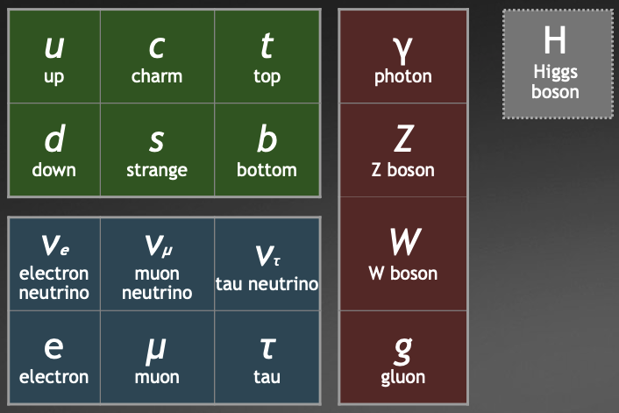

A QUESTION OF CHARGE
The electrostatic force of repulsion between two protons 1.6 x 10⁻¹⁵ m apart in the nucleus of an atom is 90 N.
The strong force, which holds quarks together, also stops the nucleus from flying apart.
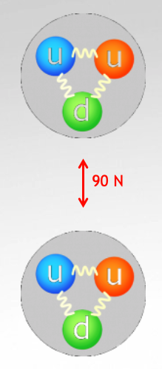

THE RELATIVE STRENGTH OF THE FORCES
As far as we know, the four fundamental forces in nature, in order from highest strength to lowest, are;
- the Strong nuclear force,
- the Electromagnetic force,
- the Weak nuclear force and
- the Gravitational force.
The relative strength of these forces, when compared to the Strong nuclear force, are
Strong Nuclear : Electromagnetic : Weak Nuclear : Gravity
1 : 10⁻² : 10⁻⁶ : 10⁻³⁸

THE 4 FORCES OF NATURE AND THEIR MEDIATING PARTICLES
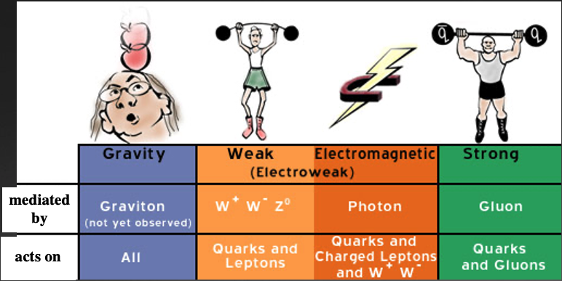
- The weak nuclear force also has its force carrying particles, known as the W⁺, W⁻ and the Z⁰ particles, which were discovered in 1983 at CERN.

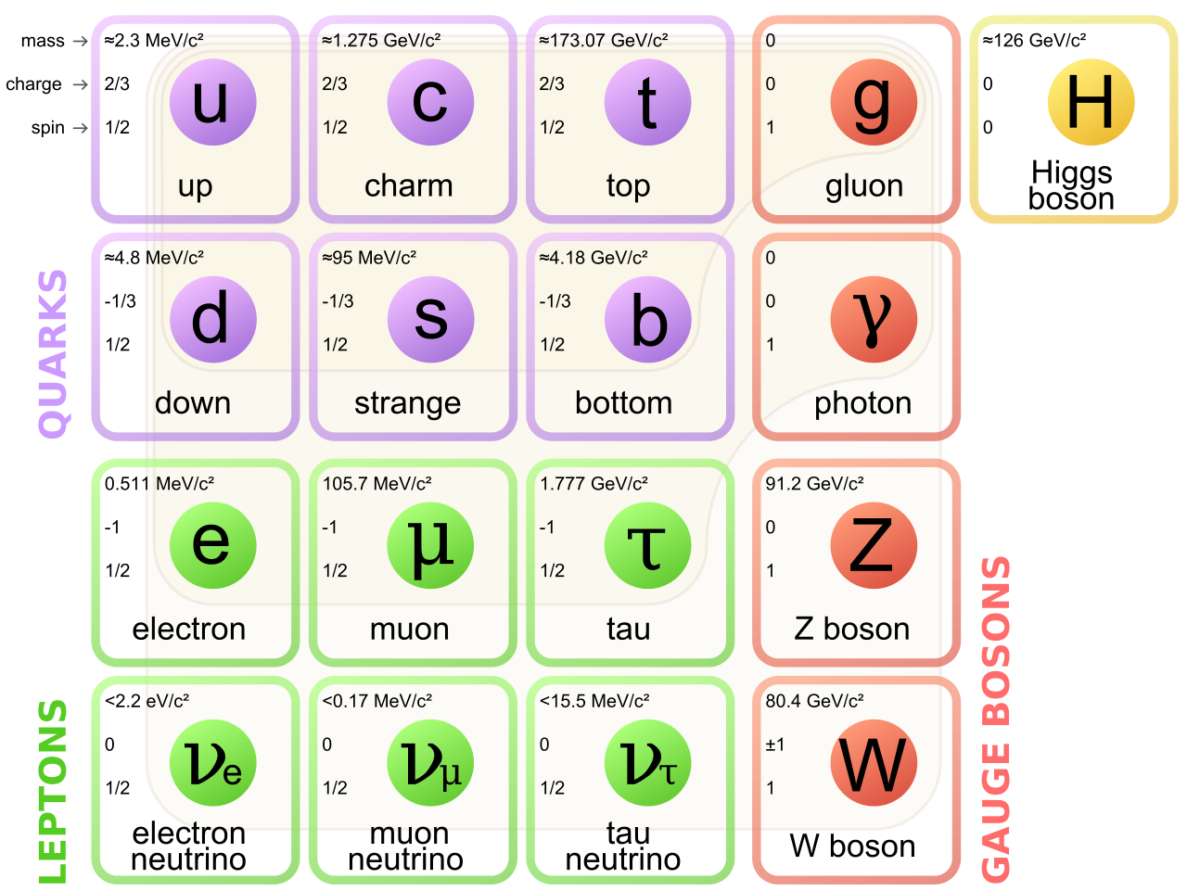
Quarks and leptons are arranged in three “generations”. Ordinary matter – atoms made of protons, neutrons, and electrons – is contained in the “first generation”. The others are though to have existed in the early stages of the universe, but are seen by us today only at powerful particle accelerators or in cosmic rays.

Additional questions for thought
What prevents quarks of like charges from repelling from each other in a hadron?
- Gluon exchange leading to an attractive force stronger than the electromagnetic force.
During beta decay a neutron changes itself into a proton and an electron and antineutrino are ejected from the nucleus.
how does a neutron change into a proton?
- A down quark changes into an up quark
An electron must be created in order to conserve charge (to cancel out the positive charge of the proton) but why is an antineutrino created?
- To conserve momentum

PARTICLE PHYSICS
Particle physicists have been able to develop the Standard Model by observing countless interactions between particles. They use special relativity and conservation laws that particles must obey to analyse these observations and test their predictions.
In developing an understanding of an aspect of the universe, such as the behaviour of particles, a physicist's job is not to be happy with just observing and recording their behaviour. The goal of physics is to discover the 'rules of the game'. Once the rules are known, they can then be used to explain what is observed and predict what else is possible. These rules may come from a large number of observations, i.e. they can then be determined from watching long enough. Or a theoretical idea can be proposed, usually derived mathematically, and then experiments can be conducted to verify the prediction.

WHAT IS AN INTERACTION AND WHAT CAUSES A FORCE?
Interactions between particles (which can involve attractive or repulsive forces, decay or annihilation) that produce some change and are observed by a particle detector are commonly known as events.
In the mid 1930’s a Japanese physicist called Yukawa suggested that subatomic forces came about by the exchange of a particle or photon.
In Yukawa’s model, as the electrons approached each other both would emit photons which would, not only cause the emitting electron to recoil, but would also cause the receiving electron to retreat in the opposite direction under the impact. So, repulsion of the two like charges comes about by the exchange of photons.

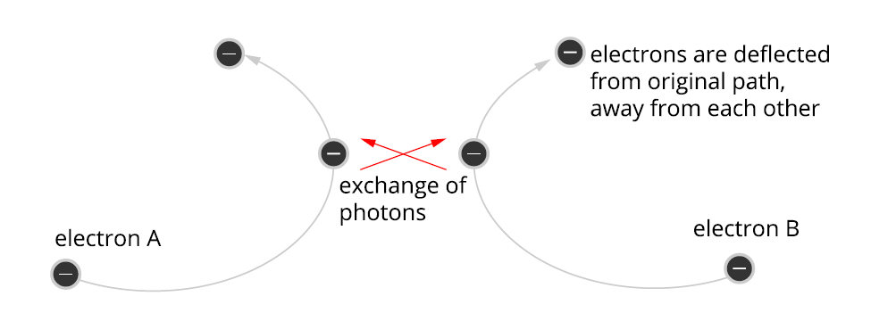
Feynman Diagrams are used to represent these interactions (attractive/repulsive forces, annihilation, etc.)

DRAWING FEYNMAN DIAGRAMS

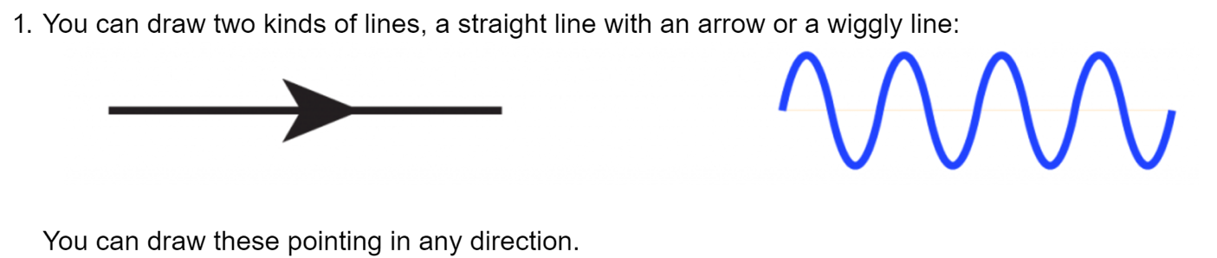
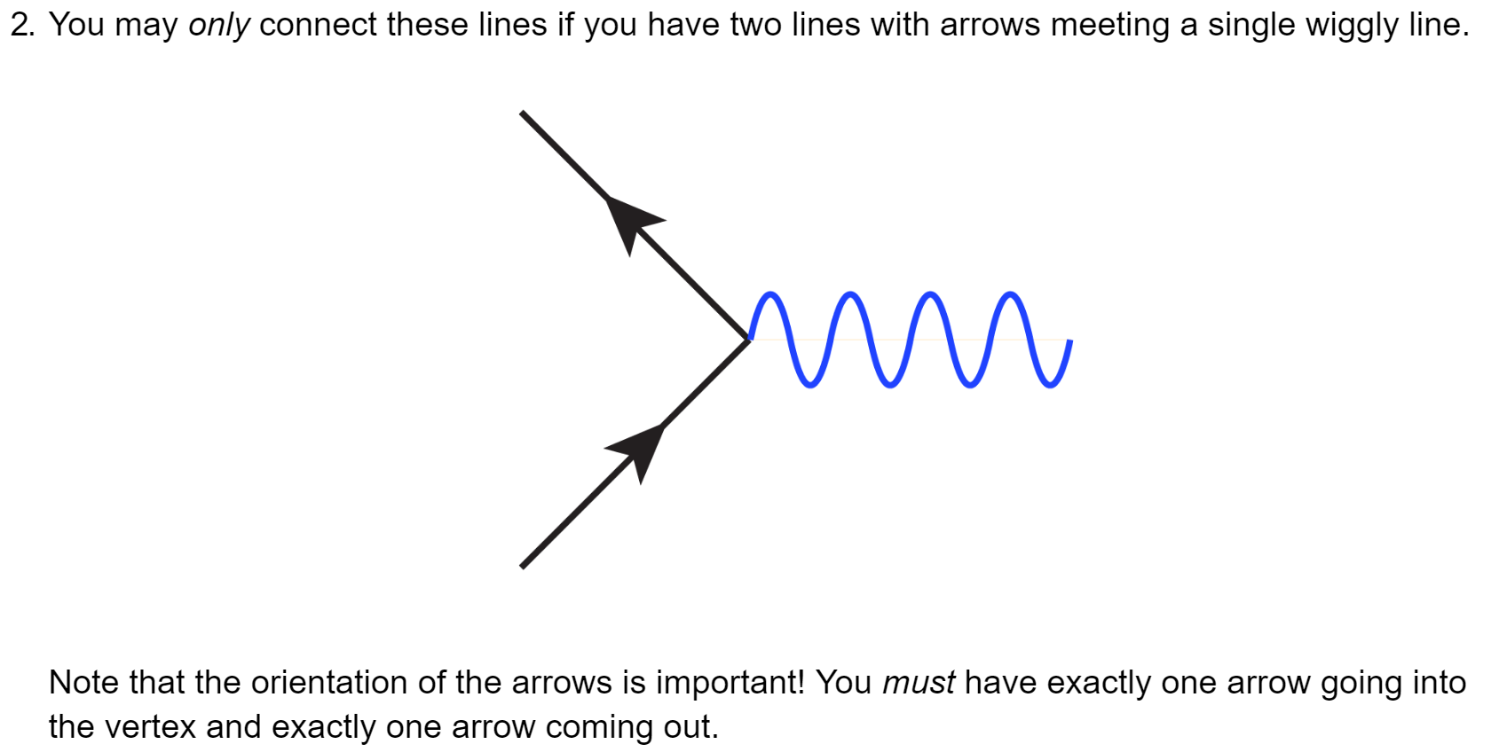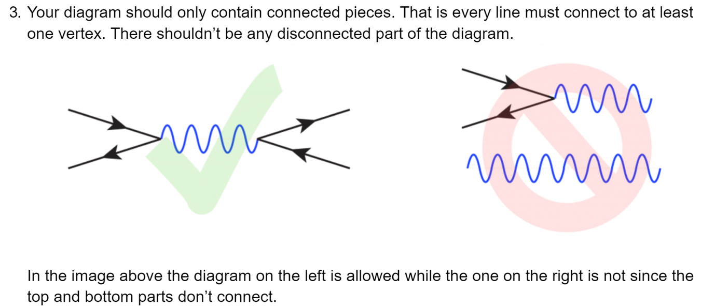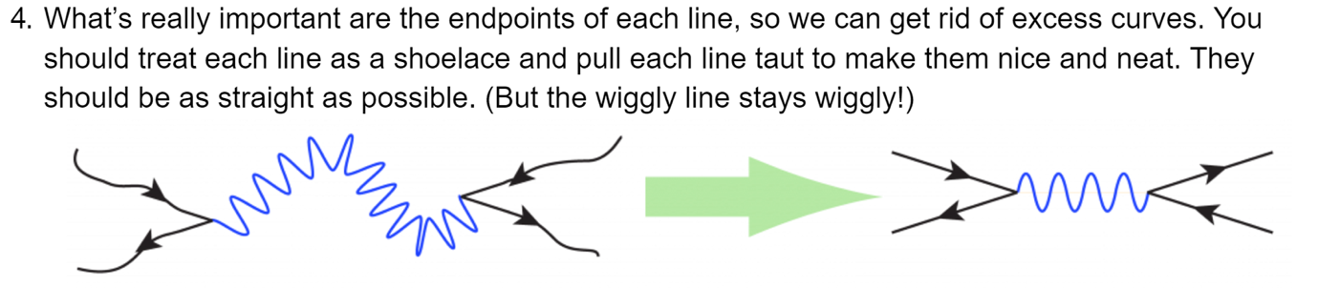

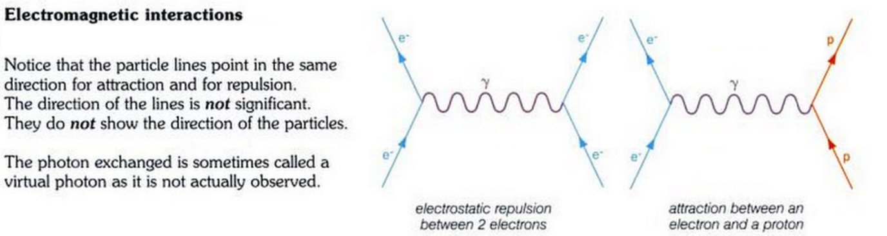
It is important to note that the directions of the arrows in these diagrams do not indicate the direction a particle travels, e.g. an antiparticle moves backwards in time.
